  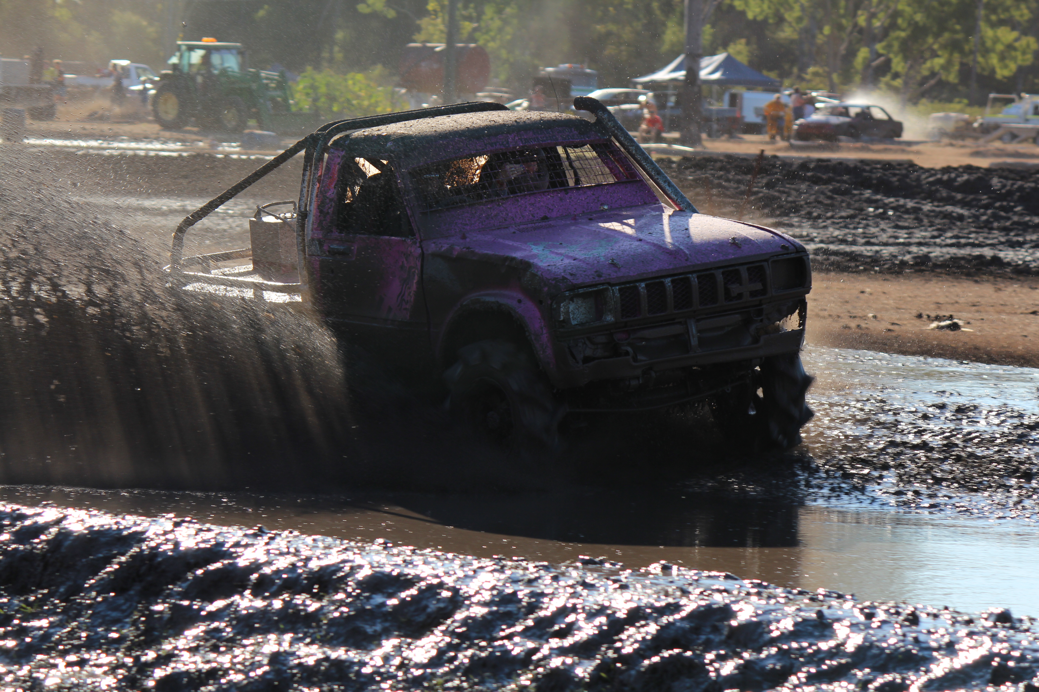
  INSANE PERFORMANCE & depco drilling presents cq mudsportz
  TWIN TRACK MUD RACING
    - 21st march STarting at 2.30pm
  Located at Kabra Motorsports Park – Behind the Kabra Pub on Scrubby Creek Road
  Prices - $50 Family (2A4C). $20 adult. $5 child (5-15years old). Under 5 years old – Free
  OTHER SPONSORS - BUDDYS FIRE, LOWES PETROLEUM
  NO ESKIES WITH ALCOHOL ALLOWED
  Racing Starts at 2:30pm.
  Bar and Canteen Facilities Available
  Juniors, Standard, Buggies and Top Guns Classes
  BYO CHAIRS and SHADE (Limited seating available)
  Full Drag and Twin Track Program
  CQ MUDSPORTZ INC
  Find us on Facebook
  

