Gear Up Rocky
Business Readiness
Video 6 Booklet

Supply Chain Collaboration
and Partnerships to Seize Opportunities
CONTENTS
1. Supply Chain Collaboration & Partnerships To Seize Opportunities 3
1.1. Collaborative Bidding 3
1.2. Two Reasons Collaborative Business Relationships Fail 4
1.3. Key Drivers of Collaborative Business Relationships 4
1.4. Co-creating Value in Collaborative Relationships 5
1.5. Collaboration Vs Partnership 5
1.6. Assessing Relationship Criticality 6
1.7. Tools for Establishing High Performance Relationships 7
1.8. Tender-Ready Activities 8
2. Next Steps 8
Appendix A: Tender-Ready Evaluation 9
Appendix b: tender-ready action plan example 10

- Supply Chain Collaboration & Partnerships To Seize Opportunities
Supply opportunities within major project supply chains can be easier to attract, secure and deliver when working closely with another business in a structured and managed relationship to achieve specific or common goals and outcomes.
Collaboration is the key to long-term business success and competitiveness.
  - Collaborative Bidding
The Queensland Government through Business Queensland provides guidance for businesses to bid collaboratively for government tenders. The guide is also useful for when forming collaborative relationships to bid on major projects. It is considered a key tactic for tendering particularly for small and medium-sized businesses. Consideration of the pros and cons of collaboration is required to assess if it is right for your business.
The most common approaches to working with other businesses are subcontracting and working in a consortium or joint venture.
The Government’s guide explains the advantages and disadvantages of collaborative bidding, the different types of collaborative work arrangements and provides a checklist of key topics for creating a collaborative agreement.
Access the following links to view the guide for How to Bid Collaboratively.
How to bid collaboratively  Increase your chances of winning tenders | https://www.business.qld.gov.au/running-business/marketing-sales/tendering/competitive/collaborative
Pros and cons of collaborative bidding  Advantages of collaborative bidding  Disadvantages of collaborative bidding | https://www.business.qld.gov.au/running-business/marketing-sales/tendering/competitive/collaborative/pros-cons
Making collaboration work  Successful business collaborations require commitment, understanding, planning and communication | https://www.business.qld.gov.au/running-business/marketing-sales/tendering/competitive/collaborative/making-it-work
Working as a subcontractor  Subcontracting is a popular collaborating option and is a good way to enter major supply chains | https://www.business.qld.gov.au/running-business/marketing-sales/tendering/competitive/collaborative/subcontractor
Working in a consortium  A consortium allows 2 or more businesses to combine their capabilities when developing and delivering a tender | https://www.business.qld.gov.au/running-business/marketing-sales/tendering/competitive/collaborative/consortium
Collaboration agreements checklist  Main points, issues and topics to address when creating a collaborative work agreement | https://www.business.qld.gov.au/running-business/marketing-sales/tendering/competitive/collaborative/checklist

  - Two Reasons Collaborative Business Relationships Fail
There are two primary reasons why supply chain collaborations or partnerships have not worked. The primary reasons for disappointment are:
- Unrealistic expectations going into the relationship; or
- Expectations were reasonable but were never articulated and agreed, hence there was no plan for achieving them, and failure was the result.
Source: Douglas M. Lambert, A. Michael Knemeyer and John T. Gardner, Building High Performance Business Relationships, Ponte Vedra Beach, FL: Supply Chain Management Institute, 2010.
Long term collaborative business relationships require both parties to assess the Key Drivers of the relationship and structure an agreed Action Plan to implement the relationship.
  - Key Drivers of Collaborative Business Relationships
There are many reasons to establish collaborative business to business (B2B) relationships. In a very basic sense, one party or both parties may lack something (e.g. expertise, equipment, people, funds, customer contacts) that the other party has and can contribute, to allow one party or both parties to achieve one or more specific goals or common goals and outcomes. If two companies are operating together in the same supply chain (e.g. a customer and a supplier), then the relationship is a supply chain relationship, and they may choose to form a supply chain collaboration.
When forming long term collaborative business relationships (especially with a key customer or a key supplier), four key drivers can be used to identify what the parties want to achieve from the relationship.
Understanding the key drivers of key business relationships is critical to articulating and communicating expectations.
Key Driver | Example Initiatives and Outcomes to Achieve During the Relationship
Asset / Cost Efficiencies | - Better utilisation of assets  - Cost reductions that might occur in areas such as transportation costs, handling costs, packaging costs, information costs, product costs, or managerial efficiencies
Customer Service Improvement | - Improvements in customer service performance to increase sales  - Helping customers to experience benefits such as reduced inventory, improved availability (which leads to increased sales), and more timely and accurate information
Marketing Advantages | - Enhancement of the company’s marketing mix through joint programs  - Entry into new markets  - Better access to technology and innovation
Profit Stability/ Growth | - Potential stabilise profit  - Strengthening a relationship often leads to long-term volume commitments, reduced variability in sales, joint use of assets, and other improvements that reduce variability of profits
Source: Douglas M. Lambert, Editor, Supply Chain Management: Processes, Partnerships, Performance, Fourth Edition, Ponte Vedra Beach, FL: Supply Chain Management Institute, 2014, p. 280.

  - Co-creating Value in Collaborative Relationships
Long term collaborative B2B key relationships can generate significant benefits when the two parties establish and implement initiatives that can achieve their Key Drivers for the relationship. This is called value co-creation.
Value Co-creation Defined: The additional revenue, cost reduction and profitability generated over time by two firms in a key business relationship exchanging services, resources and skills via cross-functional, cross-firm teams.
There are three enablers of value co-creation in B2B relationships:
- Implementation of cross-functional, cross-firm teams
- Measurement of value in financial terms
- Development of Product & Service Agreements or formal plan
Source: Douglas M. Lambert, A. Michael Knemeyer and John T. Gardner, Building High Performance Business Relationships, Ponte Vedra Beach, FL: Supply Chain Management Institute, 2010, p. 319

The objective is to structure a mutually beneficial and successful commercial relationship that will co-create substantial value.
  - Collaboration Vs Partnership
It is important to understand the difference between collaboration and partnership, for legal reasons and for the success of the relationship. If seeking to form a partnership with a key customer or key supplier, the reason for the relationship becomes much more serious.
Partnership Definition: A partnership is a tailored business relationship based on mutual trust, openness, shared risk and shared rewards that results in business performance greater than would be achieved by two firms working together in the absence of partnership. [Source: Douglas M. Lambert, Editor, Supply Chain Management: Processes, Partnerships, Performance, Fourth Edition, Ponte Vedra Beach, FL: Supply Chain Management Institute, 2014, p. 277.]
The key differences between a collaboration and partnership are summarised as follows:
Partnership | Collaboration
- For existing relationships  - Both view partnership potential  - Substantial mutual benefit  - Balanced relationship  - Can be exclusive  - Share risks and rewards  - Openness and trust  - Joint problem solving the norm | - For new relationships or when management wants to develop a plan for the next 18-24 months  - Not partners but important  - Not a balanced relationship  - Not exclusive  - May not share risks and rewards  - Problems can be solved jointly

When considering a partnership, the type of partnership required and the requirements of the relationship, needs to be identified and evaluated to determine the propensity for partnership. The greater the strategic criticality to success and the greater the value of the co-creation opportunity, the higher the level of resourcing and management the relationship will require.

Types of Relationships & Degrees of Integration
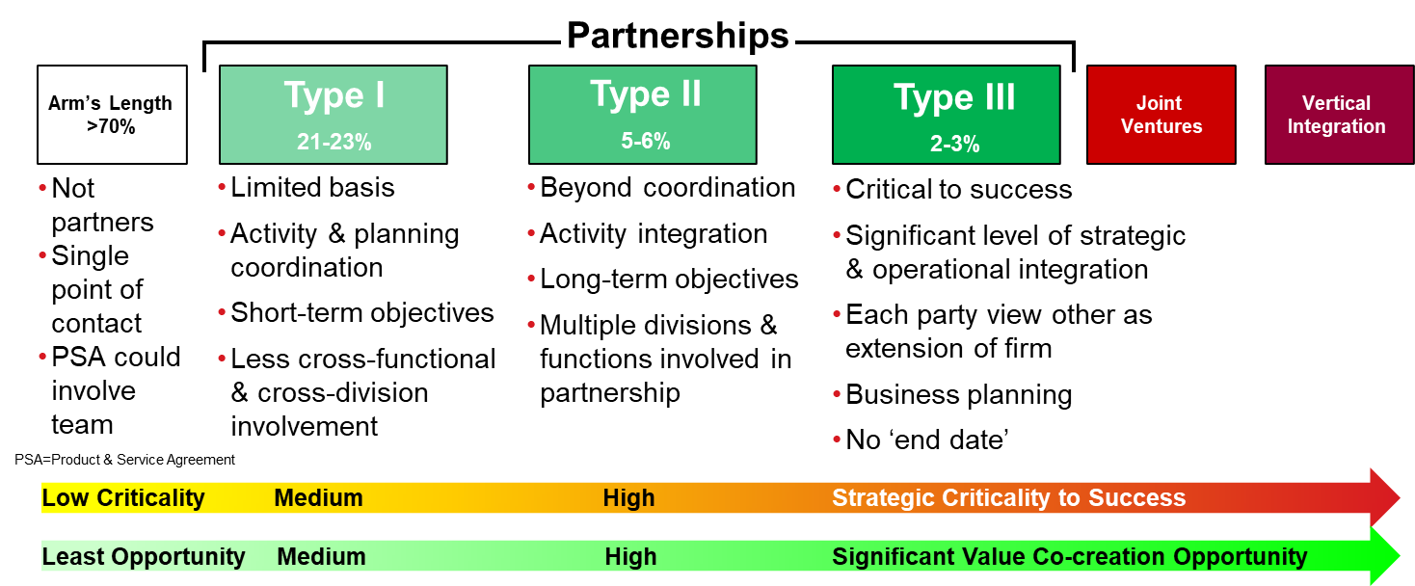
Source: Douglas M. Lambert, A. Michael Knemeyer and John T. Gardner, Building High Performance Business Relationships, Ponte Vedra Beach, FL: Supply Chain Management Institute, 2010, p. 3-5.
  - Assessing Relationship Criticality
When assessing the criticality of a key business relationship or supply chain relationship, consider the following:
- The impact on each firm if the relationship were to end
- The volume of purchases from or sales to the firm
- The involvement of the other firm in the core competency or primary product
- The availability of other sources of supply (if the other firm is a supplier)
- The percentage of the firm’s profitability (if the other firm is a customer).
Source: Douglas M. Lambert, A. Michael Knemeyer and John T. Gardner, Building High Performance Business Relationships, Ponte Vedra Beach, FL: Supply Chain Management Institute, 2010, p. 4.

The greater the criticality of the relationship, the greater the investment in resourcing the relationship to ensure it is structured and well managed.

  - Tools for Establishing High Performance Relationships
Two tools for structuring and sustaining high performance business relationships include The Collaboration Framework and The Partnership Model, owned by the Supply Chain Management Institute in Florida https://scm-institute.org/.
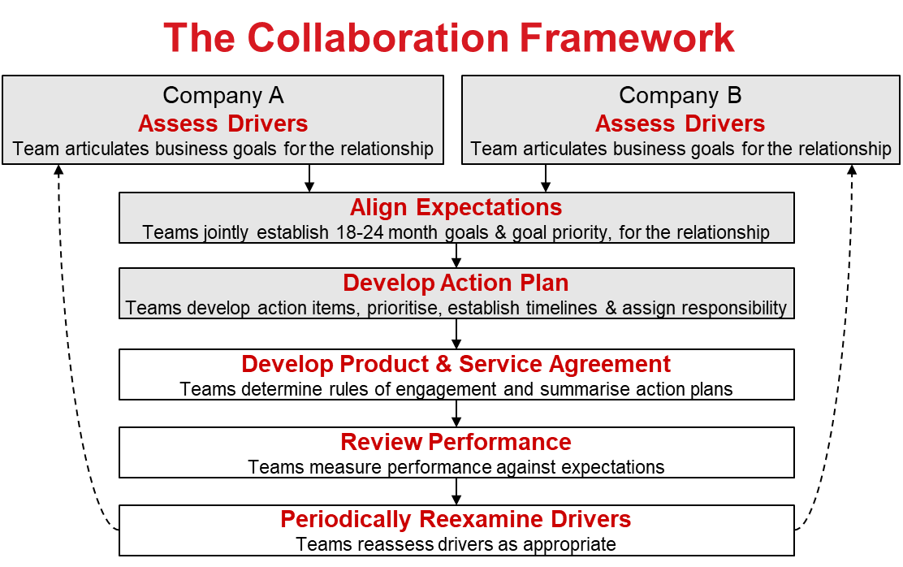

Source: Douglas M. Lambert, Editor, Supply Chain Management: Processes, Partnerships, Performance, Fourth Edition, Ponte Vedra Beach, FL: Supply Chain Management Institute, 2014.

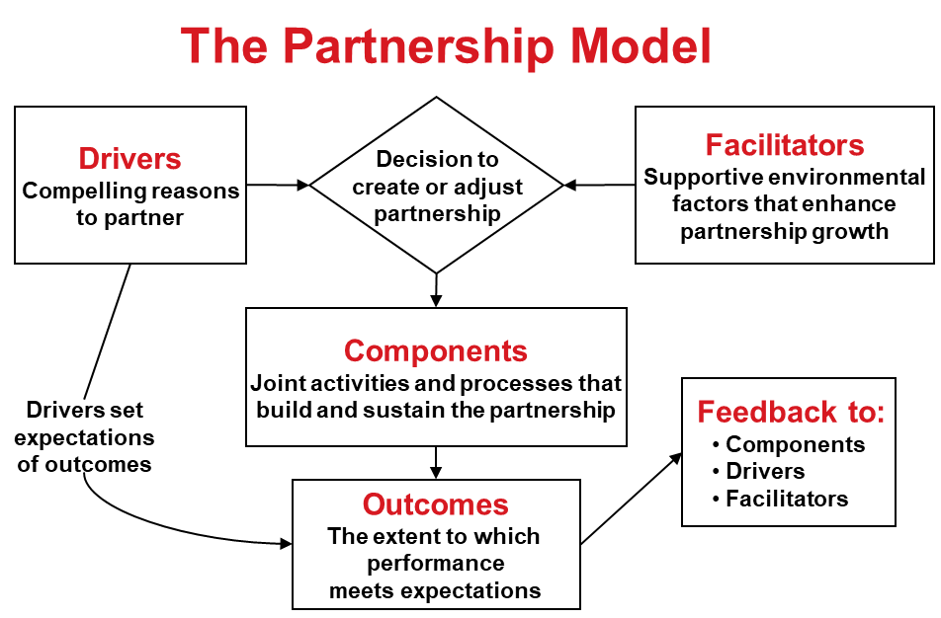

Source: Douglas M. Lambert, Editor, Supply Chain Management: Processes, Partnerships, Performance, Fourth Edition, Ponte Vedra Beach, FL: Supply Chain Management Institute, 2014.

LSC Solutions Pty Ltd http://www.lscs.com.au/ partners with the Supply Chain Management Institute in Florida to deliver these methodologies that have increased the value of corporations and supply chains in the USA and around the world.

  - Tender-Ready Activities
- Go to Appendix A and complete the Tender-Ready Evaluation for Supply Chain Collaboration & Partnerships to Seize Opportunities.
- Go to Appendix B and use the Tender-Ready Action Plan example for this topic to develop your own Action Plan.
- Next Steps
- Become an Advance Rockhampton Member and keep up to date with the latest news and business opportunities
www.advancerockhampton.com.au/sign-up
- Explore the Advance Rockhampton website for new developments, events and support
www.advancerockhampton.com.au
- Time for a recap - explore the next Video: Conclusion
For more information contact the Regional Development Team:
Phone: 07 4932 9000
Email: AdvanceRockhampton@rrc.qld.gov.au
Webpage: https://www.advancerockhampton.com.au/

Appendix A: Tender-Ready Evaluation
Supply Chain Collaboration & Partnerships to Seize Opportunities | Y: Yes  N: No  U: Unsure | S: Satisfactory  NI: Needs Improvement  NA: Not Applicable
Does your business participate in Collaborative Bidding?
Has your business had successful Collaborative Bidding experiences?
Does your business identify the key drivers of its collaborative business relationships?
Does your business establish long term collaborative relationships with key customers or key suppliers?
Does your business assess the criticality of key business relationships?
Does your business develop joint initiatives and align expectations when forming a collaborative relationship with a key customer or key supplier?
Does your business develop an Action Plan to implement joint initiatives when forming a collaborative relationship with a key customer or key supplier?
Does your business use a Product and Services Agreement for long term collaborative relationships with key customers or key suppliers?
Does your business review the performance of collaborative relationships against expectations?
Does your business measure the value of its collaborative business relationships?

Appendix b: tender-ready action plan example
Develop your own Action Plan to increase your chances of success in winning opportunities in major projects supply chains. The following Tender-Ready Action Plan template provides suggested strategies and actions.
Strategy | Actions | Responsibility | Start Due | Due Date | Success Measure
Supply Chain Collaboration Strategy | Research or receive education how to bid collaboratively.
 | Explore and evaluate opportunities to participate in Collaborative Bidding.
 | Develop ways to improve Collaborative Bidding process.
 | Identify the key drivers of collaborative business relationships.
 | Explore and evaluate opportunities to establish long term collaborative relationships with key customers or key suppliers.
 | Assess the criticality of key business relationships.
 | Establish a process to develop joint initiatives and align expectations when forming a collaborative relationship with a key customer or key supplier.
 | Establish a process to develop an Action Plan to implement joint initiatives when forming a collaborative relationship with a key customer or key supplier.
 | Establish Product and Services Agreements with long term collaborative relationships with key customers and key suppliers.
 | Review the performance of collaborative relationships against expectations.
 | Measure the value of collaborative business relationships.

