Gear Up Rocky
Business Readiness
Video 5 Booklet

Expanding Your Business
to Seize Opportunities
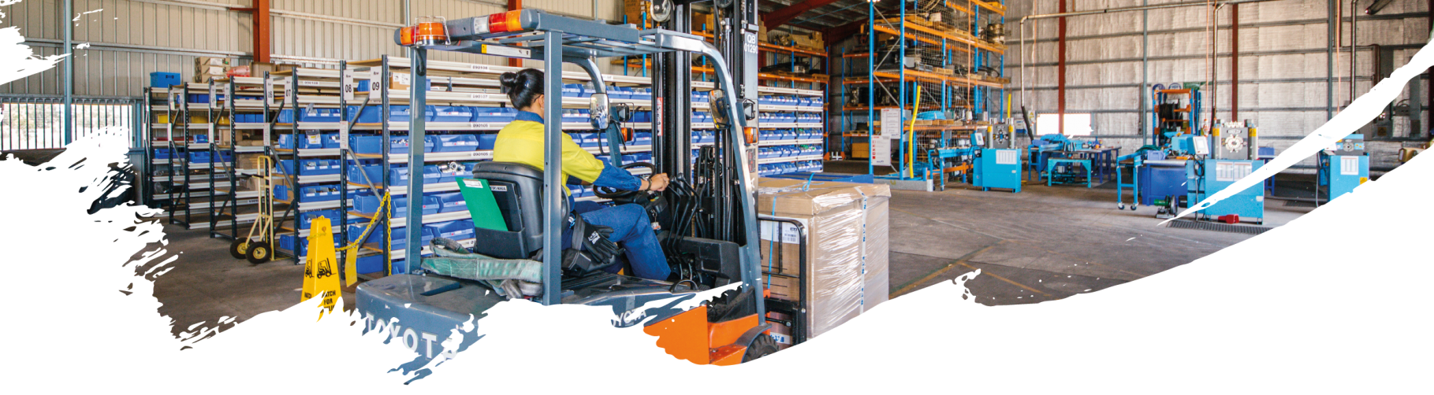
CONTENTS
1. Expanding Your Business To Seize Opportunities 3
1.1. Market Research & Analysis 3
1.2. Growing Your Business 4
1.3. Growing Human Resource Capability & Capacity 4
1.4. Expanding Business Footprint 5
1.5. Mentoring for Growth (M4G) Program 6
1.6. Jobs and Regional Growth Fund 7
1.7. Igniting METS Accelerator 7
1.8. Consider Exporting 8
1.9. Tender-Ready Activities 8
2. Next Steps 8
Appendix a: Tender-Ready Evaluation 9
Appendix b: tender-ready action plan example 10

- Expanding Your Business To Seize Opportunities
Strategic decisions to expand a business through growth and/or diversify is driven by marketplace demand and opportunities, and having sustainable capability and capacity within your business and its supply chains to respond and do the work to required standards, on time, in full and within budget. Extensive market research, business analysis and supply chain analysis is required to justify expanding, growing and diversifying a business.
  - Market Research & Analysis
- Markets:
  - Existing Target Markets: Research and identify what goods and services your target markets need.
  - New Markets: Research and explore new markets and find out what goods and/or services they need.
- Goods & Services:
  - Existing Goods & Services: Evaluate the needs of existing target markets and new markets against the goods and/or services your business already supplies.
  - New Goods & Services: Evaluate the capability and capacity of your business and its supply chains to supply new goods and/or services demanded by your existing target markets and new markets.

RESEARCH AREAS | Existing Target Markets | New Markets
Existing Goods / Services | Research & Evaluate | Research & Evaluate
New Goods / Services | Research & Evaluate | Research & Evaluate
Use your market research to identify external and internal opportunities to expand through growth and diversification, then assess the risk, issues, costs, benefits and expected return.
    - Growth & Diversification Considerations and Risks
The greatest efficiencies are achieved when supplying a small variety of goods or services to a stable marketplace that demands these goods or services on a consistent ongoing basis, at a volume that your company is capable of handling. Whilst this may be the preference for some business owners, many customers are constantly on the lookout for businesses that can provide a “one stop shop” solution with customisation capability, a quick and flexible response to their needs, at a specified volume (which could change up or down), by a specific date and within a set budget.
The greater the variety and volume of goods and/or services offered, the greater the business capability and capacity required.
Growth and diversification risks can be overcome through outsourcing and supply chain collaboration – e.g. collaborating with other suppliers with capabilities that complement your business’s goods and services, to achieve and satisfy the “one stop shop” demand.
GROWTH RISKS | Marketplace Satisfaction | Business Capability & Capacity
Low Volume of Goods / Services | Low - Medium | Low
High Volume of Goods / Services | High | High

DIVERSIFICATION RISKS | Marketplace Satisfaction | Business Capability & Capacity
Low Variety of Goods / Services | Low - Medium | Low
High Variety of Goods / Services | High | High
Alternatively, you may decide to grow and diversify your business to take advantage of marketplace demand and opportunities.
  - Growing Your Business
The Queensland Government through Business Queensland offer many ideas how to grow your business, including finding new customers, innovation, research and development (R&D), and new product development. Information is offered in the following areas: https://www.business.qld.gov.au/running-business/growing-business

Ways to grow your business  - Getting ready to grow  - Pros and cons of business growth  - Plan for business growth  - Options for growing your business  - Ways to grow your business - case study video | Responding to rapid growth  - Responding to cash flow shortfalls  - Responding to staffing and skills shortages  - Outgrowing premises  - Continuing with good customer service | Ways to transform your business  - Use a framework to transform your business  - Business transformation through innovation  - Innovate your business model  - Improve your innovation process  - Develop leaders, culture and the right team
Mentoring for Growth program  - Register your business with Mentoring for Growth  - Register as a mentor with Mentoring for Growth | Business mentoring  - Benefits of mentoring for your business  - Finding a mentor through mentoring programs  - Becoming a business mentor | Trend analysis for business improvement  - Choosing trends and results to analyse  - Developing a trend analysis system  - Analysing trends to improve business
Tips for improving your business  Being an entrepreneur  Research and development (R&D) | Becoming an innovative business  - Innovation: the basics  - Innovation readiness quiz  - Mentoring for innovation  - Support for your innovation journey  - Innovation grants and support  - Funding for innovation | Finding new customers  - Converting contacts to leads  - Ways to identify leads  - Converting leads to prospects  - Organising information about prospects
Tendering  - Determining your capability and planning your tender response  - Analysing the tender request  - Understanding the buyer  - Developing a competitive tender response  - Finalising and submitting the tender response  - Dealing with the tender process outcome | Exporting: the basics  - Support to help your business go global  - Creating an export plan  - Customs, quarantine and sanctions  - Export support | Marketing and sales  - Sales  - Tendering  - Marketing and promotion  - Trading hours  - Managing business relationships
Advice and support  - Support  - Tools  - Grants | Working with business advisers  - When to get business advice  - Types of business advisers  - Finding a business adviser  - Choosing the right business adviser  - How to work with business advisers | Creating a website  How your business can get involved in the Commonwealth Games
Source: https://www.business.qld.gov.au/running-business/growing-business
  - Growing Human Resource Capability & Capacity
Another significant milestone towards the development of the Adani, Carmichael Mine has been reached with Adani launching a job seeker portal through the uWorkin platform: https://jobsportal.adaniaustralia.com/
Adani Australia supports all employment opportunities in the communities in which they operate.
✔ people looking for work
✔ employers keen to find workers.
The Jobs Portal is a FREE service which aims to support jobs seekers find employment within Adani, their Contractors and a whole range of local employers operating in the region. Businesses within the Rockhampton Region should take advantage of this opportunity to use the Jobs Portal to fill vacant positions and to grow your business.
  - Expanding Business Footprint
    - Gracemere Industrial Area
The Gracemere Industrial Area (GIA) is growing into one of Queensland’s premier transport and logistics hubs, which will benefit Central Queensland’s mining and agricultural industries. GIA is located 10km west of Rockhampton and is bounded to the north by the Capricorn Highway and Blackwater rail line. It is positioned between the townships of Gracemere and Stanwell.
The GIA has positioned itself to specialise in developments from the following sectors:
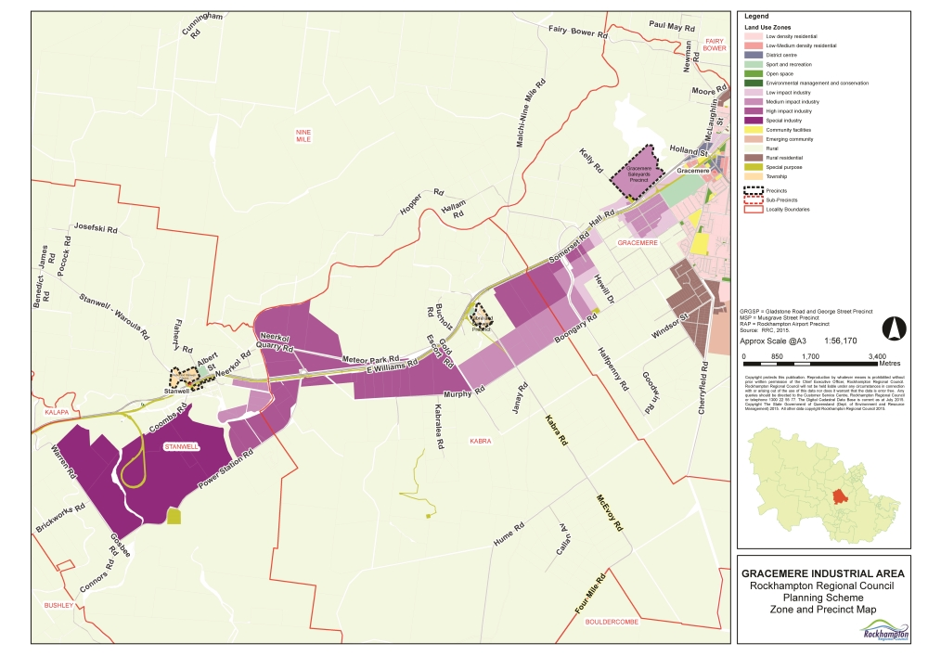
- Mining, gas and energy
- Transport
- Freight and logistics
- Agriculture and food processing
- Manufacturing
- Construction.
Industry Zones
Development of industrial land is staged to match planned infrastructure provision, and is staged generally from east to west. Industrial land is designed and available for a comprehensive range of industries categorised from low impact through to high impact industry. The Gracemere Industrial Area zone map is provided:

Source: http://www.rockhamptonregion.qld.gov.au/For-Business/Gracemere-Industrial-Area
GIA is centrally located to serve Queensland’s mining operations, with the Bowen, Surat and Galilee Basins located within a 400km radius, Gladstone Port 110km away, and only 600km to Queensland’s capital Brisbane. Strategically positioned with access to key transport, infrastructure and services, with zoning for all industrial purposes, and access to a highly skilled workforce, the Gracemere Industrial Area is available for development.
Source: http://capricornenterprise.com.au/economic-development/moving-to-the-region/gracemere-industrial-area/

    - Parkhurst Industrial Area
The Parkhurst Industrial Area (PIA) is growing into a prime transport and logistics hub, which will benefit Central Queensland’s manufacturing and construction industries. PIA is located 9km north of Rockhampton, in the south-west area of Parkhurst, a suburb of Rockhampton.
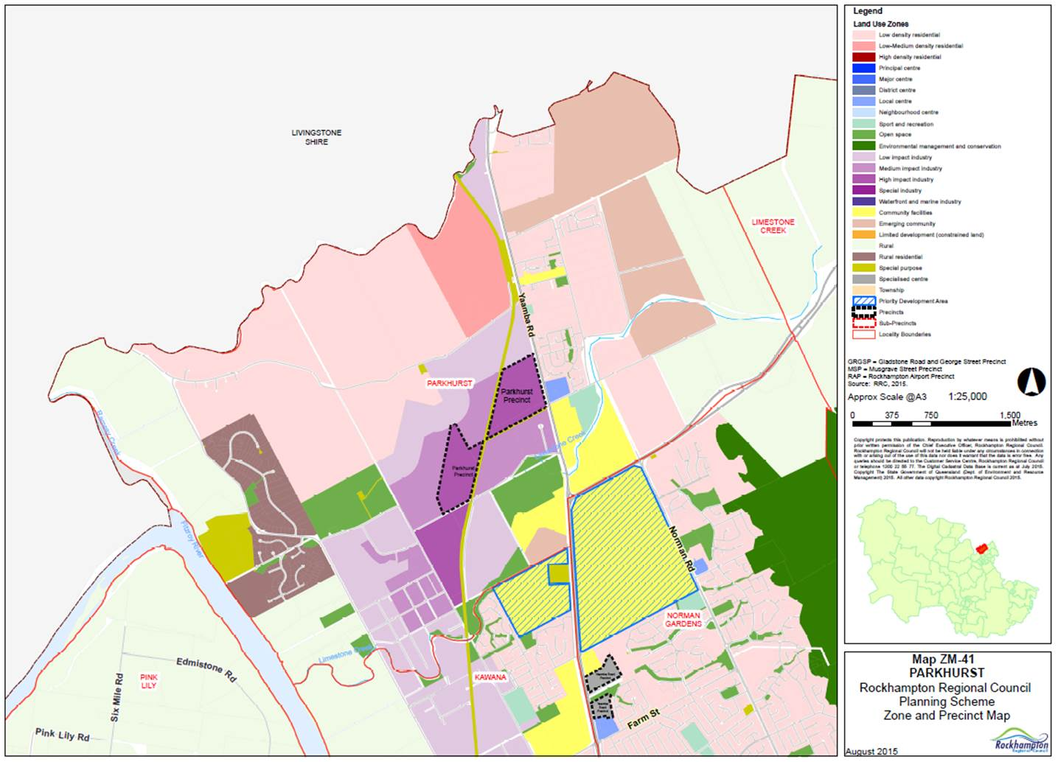
The PIA is being positioned to specialise in developments from the following sectors:
- Transport
- Freight and logistics
- Construction.
Industry Zones
Development of industrial land is staged to match planned infrastructure provision, and is staged generally from east to west. Industrial land is designed and available for a comprehensive range of industries categorised from low impact through to high impact industry. The Parkhurst Industrial Area zone map is provided:

Source: Rockhampton Regional Council
  - Mentoring for Growth (M4G) Program
The Queensland Government through Business Queensland offers eligible businesses access to a panel of up to 6 volunteer business experts who during a meeting of around 90 minutes, offer insights, options and suggestions on business challenges relating to growth and innovation.
If you are selected for M4G, the Queensland Government will match panelist expertise and experience with business issues you have identified as causing you concern or difficulty. Mentor panelists are drawn from a Queensland-wide pool of around 300 active and registered mentors. All mentors have expertise and experience in coaching and developing businesses. Panels are held in all major centres in Queensland and by videoconference. Specialised panels can be convened to assist businesses with investment readiness, export readiness, and disaster recovery.
Register for M4G here:
Source: https://www.business.qld.gov.au/running-business/growing-business/mentoring-growth/register-business

  - Jobs and Regional Growth Fund
Businesses across the state continue to put their hands up for economic growth and job creation opportunities. The $130 million Jobs and Regional Growth Fund has attracted enquiries from diverse enterprises with projects ranging from cocoa production and alternative uses for agricultural materials to mining developments.
A number of applications are close to reaching fruition, which will result in investment flow into regional Queensland industries and significant direct and indirect employment and economic benefits for their communities. Dr Anthony Lynham MP, Minister for State Development and Minister for Natural Resources and Mines announced the first grants from the $20 million Made in Queensland program.
Toowoomba manufacturers Gessner Industries and Global Rotomoulding have been awarded the first $175,000 boost to improve systems, processes and skills to grow their businesses. More than 400 Queensland manufacturers have registered interest for the program that will help drive the Queensland manufacturing sector's transition to advanced manufacturing.
Source: http://www.statedevelopment.qld.gov.au/news-and-events/queensland-economic-buzz-winter-2017.html#cover/7
Jobs and Regional Growth Fund:
http://www.statedevelopment.qld.gov.au/industry/industry-support/jobs-and-regional-growth-fund.html
The $130 million Jobs and Regional Growth Fund is part of the government’s broader $200M Jobs and Regional Growth Package, targeted at growing regional economies and jobs for Queenslanders. The fund will help facilitate private sector projects which create employment and economic growth opportunities in regional areas outside South-East Queensland facing significant economic and employment challenges. Financial assistance ranging from $100,000 to over $10 million is available for proponents to apply directly. Applications will be assessed under an appropriate set of criteria and the type and level of assistance will be determined on a case-by-case basis. Applications will be considered across a broad range of medium to large businesses, for both new projects and expansion of projects in Queensland that maximise benefits for regional employment and economic growth.
For more information on how to apply email projects@dsd.qld.gov.au or phone 1300 785 106.
Brochure: http://www.statedevelopment.qld.gov.au/resources/brochure/jobs-and-regional-growth-brochure.pdf
  - Igniting METS Accelerator
METS: Mining equipment, technology and services
The Igniting METS Accelerator is a joint initiative between the Queensland Government and METS Ignited—the national growth centre for METS—and operated by KPMG. Focused on companies with a prototype or other well-advanced product or service, the accelerator will connect them with the financial, legal and technical advice they need. Industry boot camps in Toowoomba and Mackay will help potential participants fine-tune their pitches and give them the best chance of entering the program.
This Accelerator complements Advance Queensland's Industry Accelerator Program, which focuses on METS companies in earlier stages of the commercialisation process. Between these two programs, any of Queensland's 800-plus METS companies with an innovative idea have a clear pathway to turn that idea into a commercial reality.
The Igniting METS Accelerator is a pilot program, the learnings from which will inform the design of future METS accelerators for companies across Australia.
For more information on the Igniting METS Accelerator, visit www.ignitingmets.org.
Source: http://statedevelopment.qld.gov.au/industry-development/igniting-mets-accelerator.html
  - Consider Exporting
Growing your business through exporting:
- gives you access to a larger pool of customers
- spreads your risk
- reduces your dependence on the Australian market.
Source: https://www.business.qld.gov.au/running-business/growing-business/exporting-basics

Adani Australia is interested in suppliers with exporting capabilities to export goods and services of interest to India. Adani are keen to build long term trade relationships between Australia and India.

The Queensland Government through Business Queensland offers:
- Support to help your business go global
- Creating an export plan
- Customs, quarantine and sanctions
- Export support
Find out more: https://www.business.qld.gov.au/running-business/growing-business/exporting-basics
  - Tender-Ready Activities
- Go to Appendix A and complete the Tender-Ready Evaluation for Expanding Your Business to Seize Opportunities.
- Go to Appendix B and use the Tender-Ready Action Plan example for this topic to develop your own Action Plan.
- Next Steps
- Become an Advance Rockhampton Member and keep up to date with the latest news and business opportunities
www.advancerockhampton.com.au/sign-up
- Explore the Advance Rockhampton website for new developments, events and support
www.advancerockhampton.com.au
- Explore the next Video: Supply Chain Collaboration & Partnerships to Seize Opportunities
For more information contact the Regional Development Team:
Phone: 07 4932 9000
Email: AdvanceRockhampton@rrc.qld.gov.au
Webpage: www.advancerockhampton.com.au/

Appendix a: Tender-Ready Evaluation
Expanding Your Business to Seize Opportunities | Y: Yes  N: No  U: Unsure | S: Satisfactory  NI: Needs Improvement  NA: Not Applicable
Does your business conduct Market Research to identify what goods and services your target markets need?
Does your business research and explore new markets and find out what goods and/or services new markets need?
Does your business evaluate the needs of existing target markets and new markets against the goods and/or services your business supplies?
Does your business evaluate the capability and capacity of your business and its supply chains to supply new goods and/or services demanded by your existing target markets and new markets?
Does your business manage growth risks and/or diversification risks adequately?
Does your business lack the required human resource and skills capability and capacity?
Does your business need to expand its business footprint?
Does your business require mentoring in growth and investment?
Does your business need funding to grow? Is your business eligible for the Jobs and Regional Growth Fund?
Does your business export or has it considered exporting its goods and services?

Appendix b: tender-ready action plan example
Develop your own Action Plan to increase your chances of success in winning opportunities in major projects supply chains. The following Tender-Ready Action Plan template provides suggested strategies and actions.
Strategy | Actions | Responsibility | Start Due | Due Date | Success Measure
Business Expansion Strategy | Conduct Market Research to identify what goods and services target markets need.
 | Research and explore new markets and find out what goods and/or services new markets need.
 | Evaluate the needs of existing target markets and new markets against the goods and/or services the business supplies.
 | Evaluate the capability and capacity of the business and its supply chains to supply new goods and/or services demanded by existing target markets and new markets.
 | Establish or review the company’s approach to managing growth risks and diversification risks.
 | Review human resource and skills capability and capacity in alignment with Strategic Business Plan.
 | Review business footprint requirements in alignment with Strategic Business Plan.
 | Enquire about the Queensland Governments’ Mentoring for Growth Program.
 | Conduct financial analysis to identify whether the business needs funding to grow.
 | Research and identify whether the business is eligible for the Jobs and Regional Growth Fund.
 | Explore and evaluate exporting opportunities and capabilities.

