Gear Up Rocky
Business Readiness
Video 2 Booklet

Major Projects Supply Opportunities and Tendering Requirements
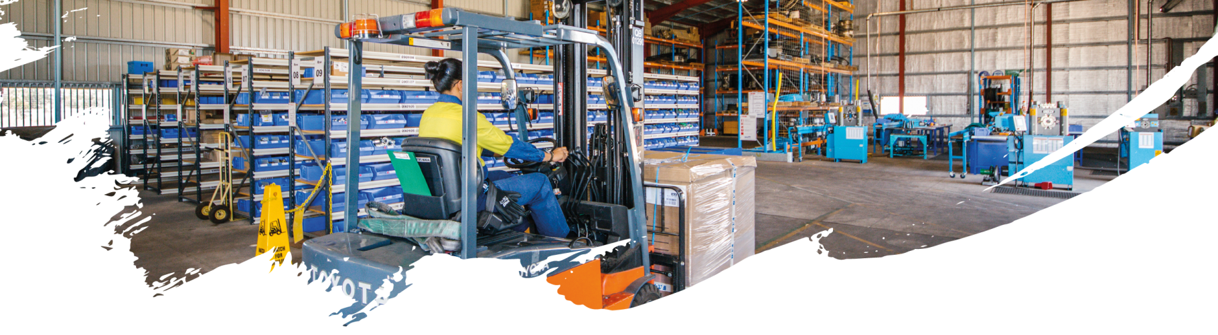
CONTENTS
1. Major projects Supply Opportunities & Tendering Requirements 3
1.1. Typical Goods & Services Required by Major Projects 3
1.2. Typical Goods & Services Required by Major Project Suppliers 5
1.3. Supply Chain Fit 5
1.4. Local Content Code of Practice 7
1.5. Adani Australia Carmichael Coal Mine and Rail Projects 7
1.6. Other Major Projects Supply Chains 10
1.7. Finding Major Projects Information 17
1.8. Tender-Ready Activities 19
2. Next Steps 20
Appendix a: Adani News & INFORMATION 21
Appendix B: Tender-Ready Evaluation 22
Appendix c: Tender Checklist example 23
Appendix D: tender-ready action plan example 24

- Major projects Supply Opportunities & Tendering Requirements
  - Typical Goods & Services Required by Major Projects
The Major Project Life Cycle determines what goods and services are required by a major project in each stage. The life span of a major project can be from several years (multi-million-dollar projects) to up to 60+ years (multi-billion-dollar projects).
The following example identifies the life cycle of a mine project, and typical goods and services required in each stage.
Life Cycle Stages of a Mine Project | Example of Goods and Services Required
1. Exploration: Generative Stage | Specialist Exploration Services:  - Geoscientific information analysis  - Prospecting, mapping and geochemical sampling activities  Refer Example Goods and Services on the next page
2. Exploration: Primary Exploration Stage | Specialist Exploration Services  - Exploratory drilling or trenching  - Intensive sampling and geochemical analysis  - Professional expertise in safety and risk management, community and environmental management and project, information and financial management.  Refer Example Goods and Services on the next page
3. Exploration: Evaluation Stage | Specialist Exploration & Evaluation Services:  - Geoscientific and engineering assessments of mine design infrastructure availability, environmental impacts, stakeholder issues influencing a project’s social license to operate  - Detailed financial analysis of costs and revenue projections and market assessment  - Scoping studies, Preliminary feasibility study, Feasibility study  - Investigation of the total environmental and socio-economic impacts  Refer Example Goods and Services on the next page
4. Development Stage: which can include Mine, Rail and Port Construction | - Pre-construction services to prepare the mine site for construction  - Construction of worker camps, administration buildings, warehousing  - Construction of Open Cut and/or Underground infrastructure including Coal Handling and Preparation Plant  - Construction of civil infrastructure, railway infrastructure, port infrastructure, power infrastructure, water infrastructure, sewerage treatment infrastructure  - Supply of plant, mining equipment, vehicles, office equipment, technology, inventory, power, water, people, etc.  Refer Example Goods and Services on the next page
5. Production Stage | Refer Example Goods and Services on the next page
6. Mine Closure and Rehabilitation Stage | - Care and maintenance services  - Rehabilitation services (health and safety, environmental, waste removal, hazardous material removal, water testing, land stabilising, vegetation)  Refer Example Goods and Services on the next page
7. Monitoring and Evaluation Stage | - Environmental monitoring services  Refer Example Goods and Services on the next page
8. Lease Relinquishment Stage | - Government assessment of rehabilitation outcomes
Source: Adapted from http://www.minerals.org.au/resources/gold/life_cycle_of_a_mine
Regardless of the type of project, a large portion of major project spend occurs during the Development Stage and Production Stage. Examples of the goods and services typically required by major projects supply chains is provided:
Example GOODS required by Major Projects Supply Chains | Example SERVICES required by Major Projects Supply Chains
- Amenities equipment (e.g. office furniture, kitchen wares, bathroom wares)  - Bulk materials  - Conveyor belting & parts  - Drilling machines  - Drive/well heads, switches, pressure gauges, ball valves, check valves, etc.  - Electrical products (e.g. lighting, SCADA, solar, radio, etc.)  - Fencing, timber supply, sheeting, belts, seals, hoses, lubricants, etc.  - Fibre optic  - Fuel  - Gas gathering systems - supply of poly pipe, fittings & valves, trenching and laying of gathering pipe  - Gear boxes  - Gensets, control equipment, steel pipe fittings, valves, compressors, pumps, clamps  - Geotechnical - supply of geotechnical equipment  - Instrumentation  - Loaders, tilt trays, Manitou and container hire  - Major equipment purchase e.g. centrifuges, compactors, crushers, process vessels, screens (wet and dry), Underground shaft lining  - Materials – building materials, general materials  - Mining drilling & consumables  - Mobile equipment including motor vehicles  - Motors (electric)  - Non-production consumables (e.g. cleaning goods, office supplies and associated consumables etc.)  - Rail goods  - Reagents and chemicals  - Refrigeration, air conditioning and associated compressors  - Safety Supplies includes PPE gear, signs and safety surveys, first aid equipment and consumables  - Screens (underground)  - Security - supply of gates, fences, alarms, CCTV, keypads  - Technology (e.g. ERP, devices, telecommunications, mobile phones, computers, printers, barcoding, ICT services - ISP, software development)  - Tools and field tools include welder’s tools, compressor tools, grinders, machinery  - Tyres, wheels & rims  - Underground vehicles; radio control systems  - Uniforms  - Utilities - electricity, gas and water  - Warehousing, including all racking types (e.g. cantilever, gravity feed, etc) and materials handling equipment  - Water; wells - above ground and below ground  - Wear / parts consumables; Wire and cable | - Electrical services e.g. electrical installations, testing, repair  - Energy provision including power, gas and electricity  - Engineering & construction (e.g. architecture, construction engineering, civil engineering, surveying, dam lining, irrigation and plumbing, pressing, fabrication, guillotining, cropping, punching, rolling, line boring, CNC machining and metal polishing)  - Environmental services  - Exploration and land services  - Fibre optic installation and terminations  - Geotechnical - supply of sampling and geotechnical testing services  - Hire - general hire (e.g. dongas, amenities, light towers, etc.)  - Hire - materials handling equipment e.g. forklifts  - Human resource management services  - Indirect services (e.g. professional labour)  - Insurance for building, property, professional indemnity & liability  - Legal services including legal subscriptions, memberships and resources  - Maintenance and repair of OEM equipment; MRO (maintenance, repair and operations)  - Motor vehicle service agents  - Operational support services (e.g. labour hire, equipment hire, fleet leasing)  - Professional services (e.g. engineering, training & development, consulting, financial, environmental, marketing, advertising, graphical design services, printing, photography, corporate videos etc.)  - Professional subscriptions & memberships  - Project management services  - Rail services  - Refrigeration and air conditioning services  - Safety services, first aid, random testing  - Security services and patrols  - Training & education service provision of training facilities, certified instructors and associated services  - Transport & logistics transport, logistics, couriers, freight and associated supply  - Travel & accommodation services  - Trenching services  - Water services & provision for the management of water, including water carting, dam
  - Typical Goods & Services Required by Major Project Suppliers
All Major Project Suppliers require:
- “In-The-Business” Support: Goods and services that support the major project supply chains they are serving.
- “On-The-Business” Support: Goods and services, especially services, that support their company to survive, thrive, grow, expand and prosper including insurance, funding, bookkeeping, accounting, marketing, capability statement development, website development, training and development, recruitment, real estate, strategic planning, technology, legal, accounting, HSEQ, security, etc..
  - Supply Chain Fit
It is important to understand where your company sits in major project supply chains:
- Does your company supply goods and services that support major projects directly or indirectly? (i.e. indirectly through major contractors or other suppliers supplying major contractors)
  - If yes, use the Tier Barometer Assessment to identify the Supply Tier where your company best fits in major project supply chains.
- Does your company support suppliers to work “on their business”, who supply into major projects supply chains? If yes, there is no need to use the Tier Barometer Assessment.
Tier Barometer Assessment
The Tier Barometer provided by the Industry Capability Network (ICN) is designed to provide you with a report to indicate your company's position in relation to a tier of supply to a major project.
Source: http://icn.org.au/content/queensland/tier-barometer-assessment

The list of questions in the Tier Barometer is not exhaustive. Those who have used ICN’s Tier Barometer in the past will notice a significant reduction in the number of questions asked and a significantly different approach. The Tier Barometer no longer assists suppliers to understand the skills and capabilities required to win work on major projects. The Tier Barometer now only focusses on capacity, compliance requirements and staffing. It is simple and quick to complete and will deliver a preliminary indication for your company.
Sections within the Tier Barometer Assessment include:
- Company Details - Basic contact details of Company
- Company Profile - Defining the essence of your Company
- Capacity - Company job size and turnover
- Safety Management - Proof of a "safety first" culture
- Environmental Management - Demonstration of commitment to Environmentally sustainable practices
- Quality Management - System to ensure products/services consistently meet your Customer's Requirements
- Insurances - Proof to customer that required Insurances are in place
- Risk Management - System to identify and mitigate risks
- Staffing - Capability and development of staff confirmed
Source: http://icn.org.au/content/queensland/tier-barometer-assessment
Tiers Assessments are available for the following project sizes:
- Very Small Projects ($2.5m to $20m)
- Small Projects ($20m to $100m)
- Medium Projects ($100m to $500m)
- Large Projects (> $500m)
Source: http://icn.org.au/content/queensland/tier-barometer-assessment
The Tier Barometer Assessment Report you receive will:
- Identify your company as a Tier 1, 2, 3, 4 or 5 Company / Supplier
- Identify your Company Strength in each area assessed
- Provide a suggested Action Plan for your company, with a view to progressing your company to the next Tier. Actions within the plan are based on the gaps in your responses in the questionnaire.
ICN provides the following Tier descriptions:
Tier 1 | Engineering, procurement and construction management or EPCM firm: A world class supplier to a Major Project that is proficient in these areas: Customer focus, Technical capabilities and expertise, Capacity, Innovation and responsiveness, Technology and productivity, Systems, Performance track record.
Tier 2 | Firms in the group receive their opportunities directly from the Engineering, Procurement and Construction Management (EPCM -Tier 1). Typically firms in this group are suppliers of major areas of work for example, engineering design, civil construction. Tier 2 companies have Systems (safety, environmental, risk and employee management) that are in place with the Tier 1 firm. These companies have the financial capability, technology and expertise required by the major contractor.
Tier 3 | Subcontractors supplying large work packages in key areas or specialist providers of technology, equipment or services. These firms often have experience in working with major projects and have the capacity to form bidding teams for larger work packages. Firms in this group maintain a high level of customer focus and have a high level of expertise and technological innovation, however may lack the systems and proven track record required from companies in higher Tiers. Opportunities usually flow to this group either from companies in Tier 2 or directly from the Tier 1 EPCM contractor.
Tier 4 | Capable subcontractors supplying goods and services to Tier 2 and Tier 3 firms. These firms may or may not have experience in working with major projects. Typically these firms lack the financial capability to bid on and win larger work packages. However, they have potential to participate in bidding groups. Firms in the group are usually suppliers of niche products and the companies may lack the systems (safety, risk management, environmental) that are in place with higher Tier firms. Opportunities usually flow to this group from Tier 2 or Tier 3 companies and not from the Engineering, Procurement and Construction Management (EPCM -Tier 1)
Tier 5 | An essential layer in the supply chain comprising smaller capacity firms that operate as suppliers Tier 3 and Tier 4 firms. This group also includes suppliers of materials and services. Typically these firms lack the financial capability to bid on and win larger work packages. However, they have potential to participate in bidding groups. Firms in the group are usually suppliers of niche products and the companies may lack the systems (safety, risk management, environmental) that are in place with higher Tier firms. Opportunities usually flow to this group from Tier 2 or Tier 3 companies and not from the Engineering, Procurement and Construction Management (EPCM -Tier 1)
Source: http://icn.org.au/content/queensland/tier-barometer-assessment

  - Local Content Code of Practice
It is important to understand the origins of Local Content, which is a “Buy Local” Strategy. In 2013, Queensland Resources Council (QRC) led the development of the Queensland Resources and Energy Sector Code of Practice for Local Content 2013 (the Code), which is an industry-led self-regulated initiative. Compliance with the Code is voluntary but strongly encouraged, particularly among the membership of the QRC. Resources and energy companies buy locally to build supply chain value and to strengthen their social licence to operate. The Code and the Code Implementation Guideline are available at: https://www.qrc.org.au/policies/local-content/
Major project proponents and their major contractors are encouraged to “Buy Local” and are required to have a “Local Content Strategy” in place and actively implemented. Whilst Local is defined as Australia and New Zealand, major project proponents and their major contractors are encouraged to buy goods and services from business communities that are located within proximity to project operations.
In the case of Adani Australia, project operations for their three projects Carmichael Coal Mine, Rail and Port, are far wide spread from Central Queensland, Bowen Basin, Mackay and Townsville. Adani’s Regional Content Strategy is to buy locally from all business communities within these regions, if suppliers have the capability, capacity and are competitively priced. This includes: Mackay-Bowen, Townsville, Charters Towers, Rockhampton, Emerald, Clermont and Moranbah.
  - Adani Australia Carmichael Coal Mine and Rail Projects
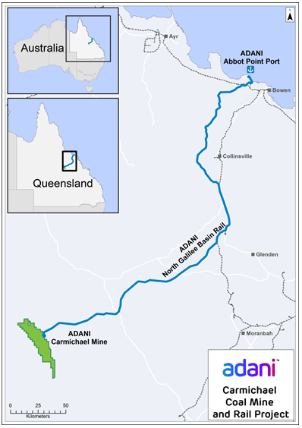
The multi-billion dollar Adani Carmichael Coal Project includes:
- Development of a thermal coal mine in Queensland’s Galilee Basin. Adani is a truck and excavator mine; draglines are not required.
- Construction of a standard gauge rail line from Carmichael mine to the Abbot Point coal terminal.
The coal from the Carmichael Coal Project will be used in power stations across India and will replace less efficient coal currently sourced from Indonesia and India. In India alone, 304 million people are unable to access any electricity (Source: IEA). This is 13 times the population of Australia. India needs to import coal to lessen energy poverty.
A unique aspect of the mine’s development is the ‘pit-to-plug’ strategy, insulating the coal from fluctuations in the global market. Source: https://economx.com/
- Adani Regional Headquarters will be in Townsville
- Adani Remote Operations Centre will be in Townsville
- Adani Rail and Port Operations Headquarters will be in Bowen
- Adani Mining Services Hub will be based in Mackay
- Adani Rail Maintenance and Provisioning Yard will be in the Mackay-Bowen region
- Adani Project Sourcing Centres will be in Townsville, Charters Towers, Rockhampton, Emerald, Clermont and Moranbah
Source: http://www.adaniaustralia.com/
- Rockhampton and Townsville are Adani’s joint Fly-in-Fly-Out hubs.

    - Adani Supply Opportunities & Tendering Requirements
Supply chain opportunities through Adani and its major contractors will include engineering, construction, maintenance, heavy machinery, equipment, transport, camps, and labour hire. This will also extend to other areas such as catering, facilities, consumables, communications, waste removal, landscaping, and cleaning. Businesses who take on work as part of the supply chain will be creating work for accountants, lawyers, professional services, real estate, office equipment suppliers, and even the local grocery store.
- Adani has commenced releasing Supply Packages on its EconomX Supplier Portal.
- Supply Packages to be released include: Rail Packages, Access Road, Onsite Civils and Earthworks, Main Accommodation, Waste Management Facilities, CHPP, and Communication. The majority of work will begin in 2018.
EconomX Supplier Portal: https://economx.com/
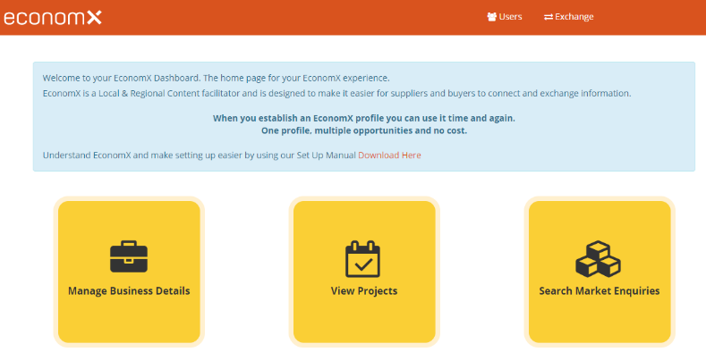
- EconomX is the official gateway for all Adani Australia supplier opportunities and is FREE to use.
- The EconomX Supplier Portal will also be a source of updates around important progress and milestones related to the Carmichael projects, giving you the facts directly.
- Major Contractors (refer next page) have their own tendering processes and will also be using the EconomX Supplier Portal.
- Download and follow instructions in the EconomX-User-Manual

Adani’s Regional Content Strategy is focused on three key drivers:
- Efficient Market Place; Effective Market Engagement; Enabling Partnerships
The Adani Regional Content Strategy was developed to ensure that suppliers based in regional Queensland are given as much opportunity as possible to be involved.
Matters Important when responding to Tenders:
- Register Your Interest in the Carmichael Coal Project on EconomX https://economx.com/
- Have an Indigenous Participation Policy – suppliers are encouraged to meet with local Indigenous groups to determine how they can work together and identify opportunities. Adani has a target of 7.5% of workforce from the traditional owners of the land, 2.5% from ex defence personnel and 10% trainees.
- Implement a local employment strategy.
- Join and be actively involved with Economic Development Organisations.
- Advance Rockhampton is Council’s Economic Development arm.
- Complete Supplier Development training with Department of State Development.
- Desirable: Have won an Award for participation in the local business community.
- Be open to joint ventures and working in collaboration.
- Marketing: Suppliers that promote their companies well using a Capability Statement and Website. Big business has advised that local businesses are missing out on million-dollar contracts due to bad websites.
- Management Systems: Big business seeks suppliers with compliant and efficient management systems for Health & Safety, Security, Environmental and Quality, and efficient and effective Information Management Systems. Certification of HSSEQ management systems depends on risk.
- Big business is interested in companies who are easy to deal with, who have timesheets and invoicing, management systems in place, project management, contract management.
- When major contractors hit the marketplace with supply opportunities, the expectation is to respond with efficiency. Cost is a major consideration – there are no huge margins and no rivers of gold.
- Preference is normally for 2-Page Capability Statements. Supplier profiles on EconomX will replace the suppliers’ Capability Statement. Suppliers will need to ensure their profile on EconomX is up-to-date.

    - Adani Australia Supply Chains – Major Contractors
Adani’s major contractors will participate in a shared services model. Tier 2 – Tier 4 suppliers are encouraged to contact Adani’s major contractors regarding potential supply opportunities. Adani have shared their Regional Content Strategy with major contractors for their review and commitment. Major Contractors have their own tendering processes and will also be using the EconomX Supplier Portal.

Major Contractor | Project | Supplier / Tendering Requirements
Downer Mining  Construction and operation of the Carmichael mine with construction commencing early 2018.  Engineering, procurement and construction contract for the mine’s new Coal Handling and Preparation Plant (CHPP)  Downer (or their subcontractors) will be directly engaging the majority of mine employees and contractors.  Similar tendering requirements as Adani. | Carmichael Coal Mine Project | Read: Supplying to Downer  http://downergroup.com/Contact-us/For-suppliers/Supplying-to-Downer.aspx  Complete: Online Supplier Registration Form  http://downergroup.com/Contact-us/For-suppliers/Supplier-registration.aspx  Downer Procurement uses different processes in sourcing and supplying goods and services dependent on those required. They range from national or local contracts, pre-qualified panels, eTendering and eCatalogues and for major construction projects suppliers often become part of their bid process. Downer Procurement will supply you with notifications of upcoming opportunities.  Monitor: EconomX https://economx.com/
Austrak  Supply of over 700,000 railway sleepers from Rockhampton-based Austrak for the Carmichael rail project. Value: $82M | Carmichael Rail Project | Monitor: EconomX https://economx.com/  Contact: http://www.austrak.com/contact-us  Similar tendering requirements as Adani.
AECOM  Pre-construction scope of work for Adani Australia’s North Galilee Basin Rail Project. Value: $28.2M - ground survey, geotechnical investigations, hydrology and detailed rail design. | Carmichael Rail Project | Monitor: EconomX https://economx.com/  Contact: http://www.aecom.com/contact-us/  Similar tendering requirements as Adani.
Liberty OneSteel  Supply of 800km rail steel (56,000 tonnes) from South Australian-based Arrium Mining and Materials Pty Ltd, to construct the North Galilee Basin Rail project. Value: $74M | Carmichael Rail Project | Read: Download the Arrium Supplier Handbook  https://www.libertyonesteel.com/terms-and-conditions/  Contact: https://www.libertyonesteel.com/about-us/contact-us/  Monitor: EconomX https://economx.com/  Similar tendering requirements as Adani.
    - Other Adani Information
Adani Abbot Point Coal Terminal: EconomX will also be used for any supply opportunities in relation to the future expansion of the Adani Abbot Point Coal Terminal. Adani is responsible for the construction of the berth, loading, rail and other on land facilities.
Adani Renewable & Agriculture: Other supply opportunities with Adani may include:
- Adani Renewables
- Adani Agriculture
More information: http://www.adaniaustralia.com/
Appendix A provides a list of Adani-related links from various websites.
  - Other Major Projects Supply Chains
    - QCoal - Byerwen Coal Project
http://qcoal.com.au/
- QCoal Group is an independent Queensland-based company that has been active in coal exploration, discovery and development since 1989.
- QCoal are committed to creating opportunities for local industry participation.
- QCoal’s contractors will give preference to suppliers of Australian-manufactured equipment that is competitively priced and complies with the relevant standards and specifications.
Major Project Supply Opportunity:
Source: http://qcoal.com.au/our-projects/byerwen-coal/
- Byerwen Coal Project
- Stage 1 Construction; First coal expected 2017
- Open-cut and Underground Mines
- 50-year mine life at 10mtpa production
- Coking coal to be exported via Abbot Point
- Stage 1 up to 100 during construction and up to 300 during operations. Up to 500 once fully operational.
- Byerwen Coal was granted the mining leases required for the project in May 2017 and the Byerwen Joint Venture has approved construction of the project. Initial contracts have been awarded and contracts have mobilised to site.
- QCoal are committed to creating opportunities for local industry participation. QCoal’s contractors will give preference to suppliers of Australian-manufactured equipment that is competitively priced and complies with the relevant standards and specifications. Suppliers are encouraged to contact QCoal at: http://qcoal.com.au/contact-us/
Tendering Requirements:
- Byerwen Coal is committed to maximising local content outcomes and is working with the Queensland Department of State Development on future supplier events and development programs.
- If you are interested in supply opportunities complete this survey: https://www.surveymonkey.com/r/KPXQLP5
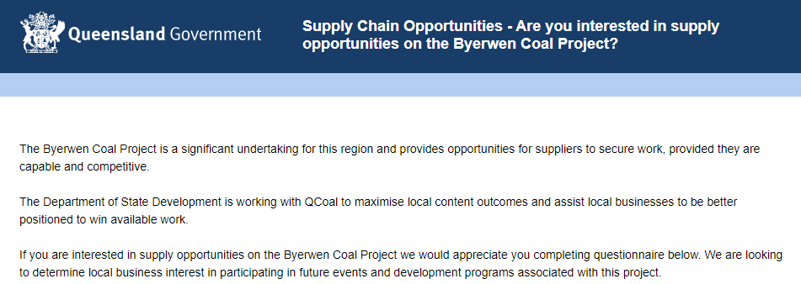
- QCoal requires suppliers to:
  - Register interest through the above survey
  - Attend supplier events
  - Complete supplier development programs organised by Queensland Department of State Development
  - Be competitively priced
  - Be compliant with industry standards
  - Have a clear and compelling value proposition
  - Demonstrate their capability
  - Demonstrate their commitment to local and traditional owner employment

- QCoal are giving preference to Australian-manufactured equipment
- Department of State Development hosted a QCoal Supplier Matching Session early August 2017 in collaboration with the Bowen Basin Mining Club and major contractor, organised by Nikki Wright
  - Nikki Wright, Regional Director, Department of State Development, Mackay
  - LinkedIn Profile: https://www.linkedin.com/in/nikki-wright-b0b03ba2/
- Department of State Development are playing a role in supply chain development and is working with QCoal and one of their prime contractors Macmahon to maximise supply chain opportunities for local businesses in the Byerwen Coal Project.
Major Contractors Supply Opportunities: Contact QCoal’s Byerwen Coal Project Major Contractors for supply opportunities and to identify their tendering requirements:
- MPC Group http://www.mpcgroup.com.au/
- Sedgman http://sedgman.com/
- Macmahon http://www.macmahon.com.au/
Contact QCoal’s Operating Mines in the Bowen Basin for supply opportunities and to identify their supplier requirements:
- Sonoma Mine http://qcoal.com.au/our-projects/sonoma-mine/
- Cows Mine http://qcoal.com.au/our-projects/cows-mine/
- Drake Mine http://qcoal.com.au/our-projects/drake-mine/
News: QCoal’s newest project is well underway – here’s how suppliers can get involved
https://www.bbminingclub.com/news/12-news/173-qcoal-s-newest-project-is-well-underway-here-s-how-suppliers-can-get-involved
    - BHP Billiton Mitsubishi Alliance - Caval Ridge Southern Circuit
Project Description Document:
http://www.bhp.com/-/media/bhp/regulatory-information-media/coal/bhp-billiton-mitsubishi-alliance/caval-ridge/caval-ridge-mine-project-draft-environmental-impact-statement-eis/creisprojectdescription.pdf
Major Project Supply Opportunity:
- Caval Ridge Southern Circuit (Bowen Basin)
- Investment: US$204 million
- Construction is scheduled to commence mid-2017 and take 18 months to complete.
- New conveyor and associated tie-ins
- New stockpile pad and Run-of-Mine station at Peak Downs
- Caval Ridge Coal Handling Preparation Plant and stockyard will be upgraded
- New mining fleet, including excavators, and trucks.
Caval Ridge Southern Circuit (CRSC) is an 11-kilometre overland conveyor system which will transport coal from Peak Downs Mine to the Coal Handling Preparation Plant (CHPP) at the nearby Caval Ridge Mine, to accelerate growth and productivity.
The project will create up to 400 new construction jobs and lock in approximately 200 ongoing operational roles. It will also result in the Caval Ridge preparation plant increasing its throughput to reach its 10 million tonne per year capacity.
The CRSC Project will create new employment opportunities during construction and locks in ongoing operational roles. The investment flowing from the project will help support the local community and State economy.
Source: http://www.bhp.com/media-and-insights/news-releases/2017/04/construction-of-caval-ridge-southern-circuit-approved
Tendering Requirements:
Source: http://www.bhp.com/info/supplying-to-bhp
- Go to the above link to find all tender requirements information.
- BHP Operating Protocols: Suppliers and contractors are required to comply with BHP’s operating protocols: BHP Charter and BHP Code of Business Conduct
- BHP Tender Terms and Conditions (go to the above link)
- BHP Purchase Order Terms and Conditions (go to the above link)
- Health Safety Environment and Community (HSEC) information (go to the above link)
    - Rio Tinto - Amrun Bauxite Project
Source: https://www.cairnschamber.com.au/fileadmin/content/Resources/CCoC_MajorProjectsListUpdate_v1F_02Dec16.pdf
- Amrun Bauxite Project
- US$1.9 billion; $2.5b for project; $1.3b annually to QLD economy
- Tendering process underway
- Production and shipping are expected to commence in the first half of 2019, ramping up to full production by the end of the year.
- Amrun involves the construction of a bauxite mine and associated processing and port facilities on the Cape York Peninsula in north Queensland.
Rio Tinto – How to Become a Supplier:
http://www.riotinto.com/documents/Amrun_project_supplier_fact_sheet.pdf
    - Other Major Mining Projects
Other mining projects of interest include:
- China Stone Coal Project (Galilee Basin)
- GVK Hancock Coal: Alpha & Kevin’s Corner Coal Projects
- Anglo American: Grosvenor Project
- Caledon Coal
- Ensham Resources
- Rio Tinto Coal: Clermont Coal Mine Project
    - Defence Major Project: Shoalwater Bay Military Zone Expansion
Australia-Singapore Military Training Initiative
A Memorandum of Understanding Concerning Military Training and Training Area Development in Australia delivers a framework to implement increased SAF unilateral training in Australia. It sets the conditions for upgrading the Shoalwater Bay Training Area and Townsville Field Training Area to deliver enhanced training outcomes for both the Singapore Armed Forces and the Australian Defence Force. Under the initiative, up to 14,000 SAF personnel will conduct unilateral training in Australia for up to 18 weeks per year – significantly increasing current personnel numbers.
Source: http://www.defence.gov.au/Initiatives/ASMTI/
Up to AUD 2.25 billion will be invested in the Townsville and Rockhampton regions from 2016 to 2026.
A KPMG study found the initiative would result in around $2b invested in Queensland, with half of that in the Fitzroy area. The expansion of Shoalwater Bay military zone is estimated to provide an annual income boost to the Fitzroy region of up to $15.9m per year during the development phase and an ongoing benefit of up to $7.3m a year once the facilities are operational.
Source: https://www.themorningbulletin.com.au/news/revealed-winners-and-losers-of-rockys-new-1b-indus/3200547/

Monitor Defence Tenders at AusTender: https://www.tenders.gov.au/
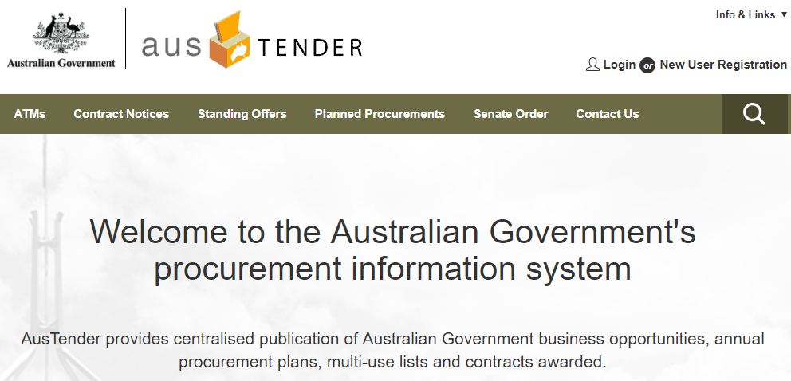
The Federal Government 2016 budget included an announcement of a long-term plan to spend $190 million in defence infrastructure and intelligence programs in the Rockhampton Region, aligned with the 2016 Defence White Paper.
Information about Defence Procurement is available at:
http://www.defence.gov.au/estatemanagement/Governance/Policy/Procurement/Default.asp
    - Capricornia Correctional Centre Expansion Project
The Capricornia Correctional Centre will undergo a $200 million expansion to provide:
- an extra 164 cells at the centre
- car park expansion
- upgrades to the waste water
- mechanical services
- electronic security systems
The expansion project will boost jobs and prison capacity. The project has commenced planning and work on site is scheduled to commence in November 2017.
The Palaszczuk Government brought forward the approval for the expansion to the Capricornia Correctional Centre to ease prison overcrowding and generate much needed jobs in Central Queensland. The project will deliver over 100 jobs to the Central Queensland region during construction and more than 70 ongoing jobs after it is commissioned, in addition to the indirect jobs it will generate in the region to keep the prison running, including for food and other service providers.
Corrective Services will work with the Department of Housing and Public Works to investigate methods of accelerated procurement and construction to commission the new high-security residential cells as quickly as practical and deliver jobs to the region. Whilst Expressions of Interest were expected to close on 27 April 2017 with shortlisted candidates invited to tender, interested parties should still contact the Department of Housing and Public Works for the latest information on this project and other major projects:
Building and Asset Services: http://www.hpw.qld.gov.au/aboutus/BusinessAreas/PWAM/BuildingAssetServices/Pages/default.aspx
Prequalification Requirements: http://www.hpw.qld.gov.au/construction/PrequalificationBuildingSuppliers/Pages/Default.aspx
Supplier Registration:
http://www.hpw.qld.gov.au/Procurement/Suppliers/PartneringBuildingAssetServices/Pages/PartneringwithBAS.aspx
Procurement:
http://www.hpw.qld.gov.au/construction/BuildingServicesGovernment/ProcurementManagement/Pages/Procurementmanagement.aspx

Contract Management:
http://www.hpw.qld.gov.au/construction/BuildingServicesGovernment/ContractManagement/Pages/Contractmanagement.aspx
eBusiness: http://www.hpw.qld.gov.au/aboutus/BusinessAreas/PWAM/BuildingAssetServices/Pages/eBusiness.aspx
News:
http://www.hpw.qld.gov.au/aboutus/News/Pages/LocalWorkersGetPriorityInCapricorniaCorrectionalCentreExpansion.aspx
http://statements.qld.gov.au/Statement/2017/4/11/local-workers-get-priority-in-capricornia-correctional-centre-expansion
http://statements.qld.gov.au/Statement/2017/1/31/200-million-capricornia-correctional-centre-expansion-boost-jobs-prison-capacity
    - Other Major Local Projects
Other major local projects include:
- Archer Park Railway Station Renewal
- Carbine Resources (http://www.carbineresources.com.au/projects/)
- Capricornia Highway upgrade (Rockhampton to Gracemere)
- CBD Car Parking Solution
- CBD Redevelopment Framework Catalytic Projects
- CS Energy Callide Power Station Overhaul (Callide, Stanwell, and the Gladstone power stations regularly seek local suppliers and sub-contractors to participate in these routine major projects)
- Cultural Precinct Development adjacent to Customs House
- Electric Car Charging Stations (Rockhampton)
- Fitzroy Agricultural Corridor
- Gavial Gracemere Road Upgrade (State Controlled Road)
- Gracemere Industrial Area
- Kershaw Gardens Redevelopment
- The Loft High Rise Development
- Mount Archer Activation Master Plan – Various Projects
http://www.rockhamptonregion.qld.gov.au/CommunityEvents/Regional-Voice/Past-Engagements/Mount-Archer-Activation-Master-Plan
- Mount Morgan Rail Station Renewal
- North Rockhampton Flood Mitigation Stage 2
- North Rockhampton Sewage Treatment Plant Augmentation
- Parkhurst Strategic Road Network
- Pilbeam Theatre Redevelopment
- Replacement programs for Rockhampton Regional Council’s core infrastructure
- Rockhampton Airport Flood Mitigation Planning and Design
- Rockhampton Airport Pavement Upgrade Project
- Rockhampton CBD Renewal Project
- Rockhampton Hospital Car Park
- Rockhampton Recreational Fishing Development Strategy – Various Projects
http://www.rockhamptonregion.qld.gov.au/CommunityEvents/Regional-Voice/Current-Engagements/Rockhampton-Recreational-Fishing-Development-Strategy
- Rockhampton Northern Access Upgrade Project
- Rockhampton Ring Road
- Rookwood Weir
- South Rockhampton Flood Levee
- Type 1 Road Train Access into Rockhampton

    - Government Major Projects
Government tender opportunities are available at: AusTender https://www.tenders.gov.au/
AusTender provides centralised publication of Australian Government business opportunities, annual procurement plans, multi-use lists and contracts awarded.
New User Registration: https://www.tenders.gov.au/?event=public.registereduser.new
Business Opportunities: https://www.tenders.gov.au/?event=public.ATM.list
Annual Procurement Plan List: https://www.tenders.gov.au/?event=public.APP.list
Information regarding Queensland Government Opportunities for Suppliers and Forward Procurement Pipelines may be found at: https://www.forgov.qld.gov.au/opportunities-suppliers
Procurement activities are organised around 6 category groups:
- Transport Infrastructure and Services
- Building Construction and Maintenance
- Social Services
- Medical
- Information and Communication Technology (ICT)
- General Goods and Services
    - Far North Queensland Major Projects
Source: https://www.cairnschamber.com.au/Regional-Major-Projects.872.0.html
The following document has 54 pages of multi-billion dollars and multi-million-dollar major projects:
- Far North Queensland (FNQ) Region's Major Projects & Investments
https://www.cairnschamber.com.au/fileadmin/content/Resources/CCoC_MajorProjectsListUpdate_v1F_02Dec16.pdf

- Cairns Shipping Development Project
Source: https://www.cairnschamber.com.au/fileadmin/content/Resources/Cairns_Shipping_Development_Project__Fact_Sheet_July_2017.pdf
  - An additional 70 cruise ships into Port of Cairns each year by 2031
  - Project design for port access by mega cruise ships up to 300 metres
  - A workable and environmentally sound land-based solution for relocation of the capital dredged material
  - No sea disposal of capital dredged material
  - Cost $120 million
  - Significant economic benefits delivering more than $848.6 million to the region
  - Potential for 800 new direct and indirect jobs during construction and more than 2,730 on completion
  - More information at Ports North:
http://www.portsnorth.com.au/
http://www.portsnorth.com.au/projects/cairnsshippingdevlproj.php
  - Contracts & Tenders: http://www.portsnorth.com.au/opportunities/contractstenders.php

    - Water Infrastructure Future Opportunities
The Australian Government – Department of Agriculture and Water Resources’ website, identifies $63M in Feasibility Studies on its National Water Infrastructure Development Fund - Feasibility Studies webpage:
http://www.agriculture.gov.au/water/national/national-water-infrastructure-development-fund/nwidf-feasibility-study
The Queensland Government, through the Department of Energy and Water Supply identifies $25M in Feasibility Studies:
- Nullinga Dam Feasibility Study - Funding of up to $5,000,000 ex GST
- Emu Swamp Dam Feasibility Study - Funding of $3,970,000 ex GST
- North West Queensland Strategic Water Storage Feasibility Study - Funding of $1,765,000 ex GST
- Lakeland Irrigation Area Feasibility Study - Funding of $825,000 ex GST
- Gayndah Regional Irrigation Development (GRID) project Feasibility Study - Funding of $1,231,024 ex GST
- Burdekin Falls Dam Raising Feasibility Study - Funding of $400,000 ex GST
- Burdekin Haughton Channel Capacity Upgrade Feasibility Study - Funding of $1,915,000 ex GST
- Bundaberg Channel Capacity Upgrade Feasibility Study - Funding of $750,000 ex GST
- Urannah Dam Feasibility Study - Funding of $3,000,000 ex GST
- Lower Fitzroy River infrastructure project Business Case - Funding of $2,000,000 ex GST
- South-East Queensland Treated Effluent Feasibility Study - Funding of $650,000 ex GST
- Southern Atherton Tablelands Irrigation Development Feasibility Study - Funding of $750,000 ex GST
- Clermont: Water Security Feasibility Study - Funding of $225,000 ex GST
- Aquifer Recharge Feasibility Study - Funding of $120,000 ex GST
- Hells Gate Dam Feasibility Study - Funding of $2,200,000 ex GST
Source: http://www.agriculture.gov.au/water/national/national-water-infrastructure-development-fund/nwidf-feasibility-study

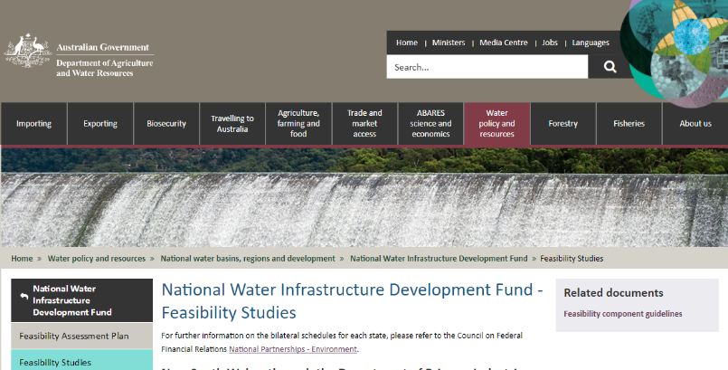

  - Finding Major Projects Information
Researching information about major projects is an ongoing task which requires commitment, time and a sustainable approach to resource this activity sufficiently, to identify and take advantage of the opportunities within major projects supply chains.
    - Industry Capability Network (ICN) Gateway
ICN helps bring Australian suppliers and project owners together by giving exclusive access to its powerful online database and our extensive network of Business Growth consultants.
Source: http://gateway.icn.org.au/
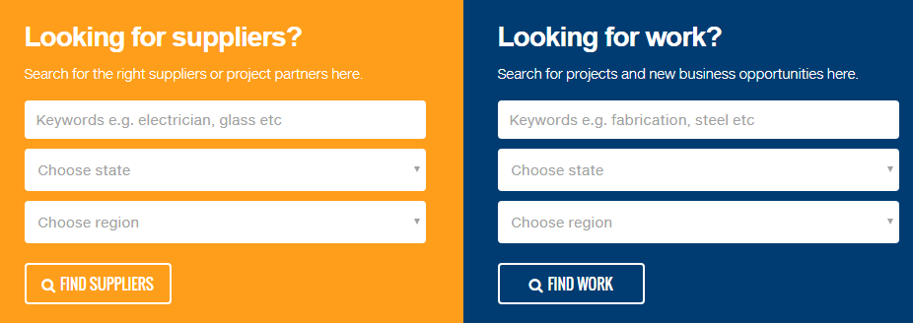
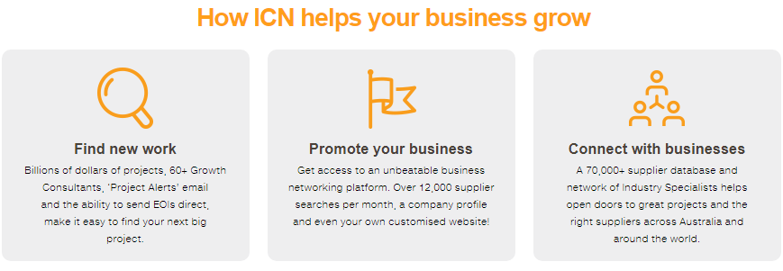
How does ICN Gateway work?
- Government and private project owners list their projects with ICN.
- Potential suppliers search for work using the ICN project database at ICN Gateway.
- Behind the scenes, ICN consultants actively work with both project owners and suppliers to build the right procurement partnerships.
You can register your Australian and New Zealand company on ICN Gateway for FREE. You can express interest in work, receive notifications and your company may be recommended to project owners when appropriate. But if you really want to promote your business, choose one of ICN’s business boosting packages.

    - Economic Development Agencies, Associations & Government
All of Queensland and beyond have an economical and vested interest in major projects in Queensland. Many entities are establishing relationships with major project proponents and their major contractors, and are seeking to deliver the latest information to their local business communities.
Therefore, information about major projects can be found in many places on the internet, especially through organisations and associations involved in economic development, those following the latest developments in major project supply chains, and those assisting with supplier development.
The following list provides a sample of the websites available which provide FREE information about major projects.

Advance Rockhampton | Rockhampton | https://www.advancerockhampton.com.au/
Rockhampton Regional Council | Rockhampton | http://www.rockhamptonregion.qld.gov.au/Home
Capricorn Enterprise | Rockhampton | http://capricornenterprise.com.au/
Capricornia Chamber of Commerce | Rockhampton | https://www.capricorniachamber.com.au/
Livingstone Shire Council | Yeppoon | http://www.livingstone.qld.gov.au/
Gladstone Engineering Alliance | Gladstone | https://www.gea.asn.au/
Gladstone Regional Council | Gladstone | http://www.gladstone.qld.gov.au/
Central Highlands Development Corporation | Central Highlands | http://chdc.com.au/  Tenders List: http://chdc.com.au/tenders/2017-2/
Central Highlands Regional Council | Central Highlands | http://www.centralhighlands.qld.gov.au/
Isaac Regional Council | Isaac | https://www.isaac.qld.gov.au/ (Majority of Adani mine and rail)
Clermont Community Business Group | Isaac | cbcg@telstra.com
Dysart Business Group Inc | Isaac | dbgi.secretary@gmail.com
Moranbah Traders Association (MTA) | Isaac | http://moranbahtraders.com.au/
Nebo Community Development Group | Isaac | https://www.nebocommunity.com.au/
Bowen Basin Mining Club | Brisbane | https://www.bbminingclub.com/
Resource Industry Network | Mackay | http://www.resourceindustrynetwork.org.au/
Regional Development Australia  Mackay-Isaac-Whitsunday | Mackay | http://www.rdamiw.org.au/
Mackay Regional Council | Mackay | http://www.mackay.qld.gov.au/
Local Buying Foundation | Mackay | http://www.localbuyingfoundation.com.au/
Mackay Regional Chamber of Commerce | Mackay | http://www.mackaychamberofcommerce.com.au/new-web-pages/new-home
Sarina Business Group | Sarina | sarinabusiness@mackay.qld.gov.au
Queensland Resources Council | Brisbane | https://www.qrc.org.au/
Bowen Collinsville Enterprise Inc. | Bowen | http://bce.org.au/
Advance Queensland | Brisbane | http://advance.qld.gov.au/  Queensland Mining Equipment, Technology and Services 10-Year Roadmap and Action Plan  http://statedevelopment.qld.gov.au/resources/plan/eid/mets-10-year-roadmap-and-action-plan.pdf

Greater Whitsunday Alliance | Whitsunday | http://www.whitsundayregion.org.au/index.htm http://www.whitsundayregion.org.au/GW3  http://www.greaterwhitsundayalliance.com.au/home
Whitsunday Regional Council | Whitsunday | http://www.whitsunday.qld.gov.au/
Charters Towers Regional Council | Charters Towers | http://www.charterstowers.qld.gov.au/ (Small portion of Adani mine)
Townsville Enterprise | Townsville | http://www.townsvilleenterprise.com.au/
Townsville City Council | Townsville | https://www.townsville.qld.gov.au/
Advance Cairns | Cairns | https://www.advancecairns.com/
Cairns Chamber of Commerce | Cairns | https://www.cairnschamber.com.au/  https://www.cairnschamber.com.au/Regional-Major-Projects.872.0.html
Northern Australia Infrastructure Facility | Cairns | http://www.naif.gov.au/
Toowoomba Regional Council | Toowoomba | http://www.tr.qld.gov.au/our-region/major-projects
Toowoomba and Surat Basin Enterprise | Toowoomba | https://www.tsbe.com.au/  https://www.tsbe.com.au/supply-chain-opportunities
Regional Development Australia | Canberra | https://rda.gov.au/
Australian Government – Department of Infrastructure & Regional Development | Canberra | http://investment.infrastructure.gov.au/projects/  http://investment.infrastructure.gov.au/funding/
    - Subscriber-based Websites
Subscriber-based websites are also available which provide considerable details, news and articles regarding the latest developments with major projects across Australia. Some of these include:
Projectory | https://secure.projectory.com.au/ information-packed articles
CoreLogic | https://www.corelogic.com.au/cordell
Shift Miner | http://shiftminer.com/
    - Websites with Relevant Information
Minesonline.com | http://www.minesonline.com/
Resources and Energy Quarterly | Produced by the Australian Government Department of Industry, Innovation and Science, which provides an overview of the global macroeconomic situation and other relevant information.  https://industry.gov.au/Office-of-the-Chief-Economist/Publications/Pages/Resources-and-energy-quarterly.aspx
  - Tender-Ready Activities
- Go to Appendix B and complete the Tender-Ready Evaluation for Major Project Supply Opportunities & Tendering Requirements
- Go to Appendix C and use the Tender Checklist example to develop your own checklist
- Go to Appendix D and use the Tender-Ready Action Plan example for this topic to develop your own Action Plan.

- Next Steps
- Become an Advance Rockhampton Member and keep up to date with the latest news and business opportunities
www.advancerockhampton.com.au/sign-up
- Explore the Advance Rockhampton website for new developments, events and support
www.advancerockhampton.com.au
- Explore the next Video: Supply Chain Promotion
For more information contact the Regional Development Team:
Phone: 07 4932 9000
Email: AdvanceRockhampton@rrc.qld.gov.au
Webpage: www.advancerockhampton.com.au/

Appendix a: Adani News & INFORMATION
http://chdc.com.au/media/2013/03/Adani-Fact-Sheet.pdf
http://statedevelopment.qld.gov.au/assessments-and-approvals/carmichael-coal-mine-and-rail-project.html
http://www.austmine.com.au/News/articleType/ArticleView/articleId/4577/Adani-Australia-Smart-Mining-Networking-Event-Write-Up
http://www.townsvilleenterprise.com.au/economic-development/economic-development-projects/carmichael-mine-and-rail-proje.php
https://jobsportal.adaniaustralia.com/news/1449/adani-project-gets-green-light
https://www.dailymercury.com.au/news/must-do-for-adani-business/3209085/

Appendix B: Tender-Ready Evaluation
Major Projects Supply Opportunities & Tendering Requirements | Y: Yes  N: No  U: Unsure | S: Satisfactory  NI: Needs Improvement  NA: Not Applicable
Does your business have goods and services required by major projects supply chains / or does your business have support services required by major projects suppliers?
Do you know where your business fits in major projects supply chains? Tier 1, Tier 2 etc.
Are you aware of Local Content Code of Practices? Does your business need to comply?
If relevant, has your business registered interest on EconomX for Adani opportunities?
Does your business have compliant and efficient management systems for Health & Safety, Security, Environmental and Quality? And efficient and effective Information Management Systems?
Does your business have a local employment strategy and Indigenous employment strategy?
Does your business attend Supplier Development training with Department of State Development?
Does your business know where to find major project supply opportunities?
Does your business know how to complete Supplier Registration for major project supply opportunities?
Does your business need to complete Supplier Pre-Qualification Requirements for major project supply opportunities?
Does your business have an efficient Tendering Process?
Does your business have a Tender Checklist to ensure all steps have been completed?
Does your business maintain a CRM Database with major project contact details and supply opportunities?

Appendix c: Tender Checklist example
The Tasmanian Government provide a great Tender Checklist, which could be use and modified to suit your businesses tendering process in alignment with your target market.
Source: http://www.purchasing.tas.gov.au/
Tick | Item | Description
 | Have you registered your interest in this tender? | If you receive your copy of the tender document from a third party, register your interest with the contracting agency so that you receive any amendments.
 | Do you understand all the requirements? | Make sure you have read the tender document and highlighted important points.
 | Do you need clarification? | If you do not understand something, talk to the agency contact.
 | When is the closing date? | When does the tender close and where should it be lodged? Late tenders will not usually be accepted.
 | Are you fully informed? | Make sure you attend any pre-tender briefing sessions.
 | Can you complete the entire contract in-house? | Can you complete the contract in-house or will you need to sub-contract or form a consortium? If you need outside help make sure you give others enough time to provide input into the tender.
 | What are the evaluation criteria? | Determine the criteria against which your tender will be evaluated and note any weighting placed on each of the criteria.
 | Do you need a tender response strategy? | For high value tenders you may wish to determine at an early stage if you can provide a competitive solution.
 | What are the contract terms and conditions? | Read the contract terms and conditions and make sure you can comply.
 | Have you identified how to respond? | How does your response need to be submitted - in a paper format or have electronic copies also been requested? How many copies are required?
 | What format do you respond in? | Are there any mandatory tender forms to be completed?  If there are, and they have not been included, your tender will be considered incomplete and will be eliminated.
 | Preparing your Response
 | Is your response in a simple format? | Your tender will be evaluated on content not on an elaborate presentation.
 | Are there tenderers response schedules? | If tenderers response schedules have been provided, use them.
 | What numbering has been used in the tender document? | If no set format for responding has been specified, follow the general format and numbering of the tender specification.
 | Have you answered all the specified requirements? | Prepare a checklist and tick each of them off as you answer them.
 | Have you provided all the information requested? | Have you been requested to supply other information and documents?
 | Have you indicated whether you comply with the conditions of contract? | If you exceed the requirements, or only partially comply, have you provided a detailed explanation?
 | Are there Quality Assurance requirements? | Are any supporting documents required? Are they attached?
 | Have you demonstrated your ability to meet all of the selection criteria? | Make sure you have clearly demonstrated (not just asserted) your ability to fulfill all the mandatory criteria.
 | Have you completed the price or cost schedule for all items you are tendering? | Have you included your costing for all items and followed the GST requirements?
 | Are you offering value for money? | Have you pitched competitively?
 | Have you contacted your referees to confirm they are willing to be a referee? | Are referee contact details correct?
 | Have there been any amendments? | Have there been any tender amendments issued and have you addressed these?
 | Is this an alternative tender? | Have you clearly identified that this is an "Alternative Tender"? Check with the agency first to confirm that an alternative proposal will be considered.
 | Submitting your Response
 | Have you signed all the appropriate forms? | Have you correctly signed all appropriate tender forms?
 | How can you send your response? | Can a fax or electronic lodgement be sent or is a hard copy required? How many copies are required?
 | What needs to be on the tender envelope? | Check to see if specific information is requested to be on the tender envelope - back and front - and how this is to be presented.

Appendix D: tender-ready action plan example
Develop your own Action Plan to increase your chances of success in winning opportunities in major projects supply chains. The following Tender-Ready Action Plan template provides suggested strategies and actions.
Strategy | Actions | Responsibility | Start Due | Due Date | Success Measure
Major Projects Supply Opportunities & Tendering Requirements Strategy | Ensure business has goods and services required by major projects supply chains or support services required by its suppliers
 | Identify where business fits in major projects supply chains
 | Understand Local Content Code of Practice and identify whether the business needs to comply
 | Comply with the proponent’s Local Content Code of Practice
 | Identify where to find major project supply opportunities
 | Register as a supplier on EconomX, ICN Gateway and major contactor websites
 | Identify Supplier Pre-Qualification Requirements
 | Increase efficiency and effectiveness of management systems for Health & Safety, Security, Environmental and Quality; and Information Management System.
 | Develop local employment strategy, an Indigenous employment strategy and consider ex defence personnel and traineeships.
 | Attend Supplier Development training with Department of State Development
 | Improve efficiency of Tendering Process
 | Develop and implement a Tender Checklist
 | Maintain CRM Database with major project supply opportunities

