

**GUIDELINES FOR CREATION AND SUBMISSION OF ADAC XML FILES**







**ADAC XML Files to Accompany the**

**“As-Constructed” Bundle of Information**

Version 1.4 (3rd October 2014)

**TABLE OF CONTENTS**

1. PURPOSE 5

2. INTRODUCTION TO ADAC XML 5

3. GENERAL REQUIREMENTS 6

4. DATUM INFORMATION 6

5. CREATION OF ADAC XML FILE(S) 6

6. Asset Capture details 7

Cadastre assets 8

Connection 8

Easement 8

LotParcels 8

RoadReserve 8

SurveyMark 8

WaterCourseReserve 8

OpenSpace assets 9

OpenSpaceArea 9

Activity Area 9

Activity Point 9

BBQ / Table / Seat / WasteCollectionPoint / BicycleFitting / Fixture / BarrierPoint / Shelter / Artwork / Tree / Sign 9

BarrierContinuous 10

BoatingFacility 10

Building 10

ElectricalConduit 10

ElectricalFitting 11

LandscapeArea 11

RetainingWalls 11

Sewerage Assets 12

Connections 12

Fittings 12

Maintenance Holes 12

Non Pressure Pipes 12

Pressure Pipes 13

Valves 13

StormWater 14

EndStructure 14

Fitting 14

GPT Complex / GPT Simple / NonGPTSimple 14

Pipe 15

Pit 16

SurfaceDrain 16

WSUDArea 16

Supplementary 17

PointFeature / PolylineFeature / PolygonFeature 17

Surface 17

Contour 17

SpotHeights 17

Transport 18

FlushPoint 18

Pathway / RoadPathway / PathStructure 18

Pavement / Parking 18

PramRamp 18

RoadEdge 19

RoadIsland 19

SubSoilDrain 19

Water Supply Assets 21

Fittings / Service Fittings / Irrigation Fittings 21

Hydrants 21

Maintenance Holes / Storage Tanks 21

Meters 21

Pipes 21

Valves 21

APPENDIX A - ADAC DATA SCHEMA 23

Global Object Model 23

Cadastre Object Model 23

OpenSpace Object Model 25

Sewerage Object Model 30

Stormwater Object Model 33

Supplementary Object Model 38

Surface Object Model 38

Transport Object Model 39

Water Supply Object Model 41

|  |  |  |  |
| --- | --- | --- | --- |
| **version**  **nO** | **Discription & DISTRIBUTION** | **DATE** | **COMMENTS** |
| 1.0 | Internal Review only | 30/06/2014 | draft for discussion |
| 1.1 | First Draft - IPWEA ADAC Consortium | 03/07/2014 | draft for discussion |
| 1.2 | Second Draft Incorporating SeQ Comments - IPWEA ADAC Consortium | 01/09/2014 | draft for discussion |
| 1.3 | Third Draft incorporating cq region comments – ipwea adac consortium | 17/09/2014 | Draft for discussion |
| 1.4 | Final draft for release to ipwea | 03/10/2014 | For distribution |
|  |  |  |  |
|  |  |  |  |
|  |  |  |  |
|  |  |  |  |

# PURPOSE

The purpose of this document is to provide practical guidelines and general assistance with respect to the creation and provision of compliant ADAC XML files. ADAC XML files are routinely required to accompany the usual bundle of “As-Constructed” plans, drawings, schedules and associated information reflecting new donated civil infrastructure and associated assets handed over to the Receiving Entity, usually a Local Authority, Water, Power or Telecommunications Utility.

On completion of physical works and prior to asset handover, “As-Constructed” (also known as “As-Built”) information is collected. The “As-Constructed” data indicates the surveyed locations of infrastructure installed as a part of the physical works to be taken over by the Receiving Entity.

The final “As-Constructed” data should accurately reflect material types, specifications and other asset-specific information. The digital ADAC XML file is a complete and detailed digital record of “As-Constructed” Plan information and is used by the Receiving Entity to populate various information systems including GIS and Asset Systems.

Note: Specific details regarding the preparation and presentation of any required “As-Constructed” drawings and plans accompanying the ADAC XML file should be sourced from the Receiving Entity allowing.

# INTRODUCTION TO ADAC XML

ADAC XML files are an accompaniment to the “As-Constructed” bundle of information required by the Receiving Entity and form a necessary part of the final approval and handover of associated civil assets and infrastructure donated or handed over via way of contractual arrangements.

Compliant ADAC XML files contain a structured and precise digital record of the assets described in the “As-Constructed” plans and other associated engineering documentation. Details include survey-accurate cadastral and boundary references, geometries and relative levels as well as detailed records of the new assets including accompanying attribute information.

ADAC XML files may also be used as a cross-check on accuracy and completeness of the “As-Constructed” information provided. The digital files afford a further confirmation of compliance with development approval conditions as well as helping to verify engineering specifications and other design-related requirements.

Depending on the tools[1] (XML generator) being used to generate the ADAC XML, compliant files are initially created during survey capture and then finalised in conjunction with the creation of the “As-Constructed” drawings (e.g. DWGs). Alternatively the XML files may be generated after the electronic “As-Constructed” drawings have been finalised. It is essential that the “As-Constructed” drawings are created using complete and survey-accurate information to correctly identify the assets and the precise locations being represented in the ADAC XML file.

Please also note that some asset types are common to multiple asset classes (e.g. lighting fixtures designed and used for the purposes of either street or park lighting). In those cases, recording assets in a different asset class to the actual service class (Open Space vs Transport) is valid and appropriate when generating the ADAC XML file. This example would see street light fittings added to the ADAC XML file under the service class of Open Space.

On acceptance of the “As-Constructed” bundle of information, the Receiving Entity will undertake data format and conformance checks on the ADAC XML file to confirm the completeness and validity of the details. Should significant anomalies, errors or missing information be identified during these checks, the ADAC XML file(s) may be returned to the provider for correction and resubmission in accordance with applicable conditions potentially delaying the progress of asset handover process.

Once accepted by the Receiving Entity, ADAC XML data file(s) are uploaded to various internal information systems and used to assist in the long-term management of the new infrastructure. The detailed asset and location data may also then be made available in the future to external agencies via digital formats.

# GENERAL REQUIREMENTS

The ADAC XML file shall be produced using the most recent ADAC XML schema release (e.g. Ver 4.1) and should be “validated” for compliance before being submitted to council. Details on the data schema (attributes and mandatory status) noting asset classes and sub-classes to be addressed by the ADAC capture process can be found in Appendix A.

The ADAC XML files are to be provided to the Receiving Entity in the format and by the means specified by the Entity.

# DATUM INFORMATION

Data contained in the ADAC XML file(s) must reflect the survey details of the assets exactly as found in the real world and as accurately reflected in the “As-Constructed” drawings. Unless otherwise specified, survey details must be derived from permanent survey marks (PSMs), where available, with Map Grid of Australia (MGA – GDA 94) co-ordinates and the relevant UTM Zone for the survey area. All AHD levels to be to fourth order standard as defined by ICSM[2] Standard for the Australian Survey Control Network Special Publication 1 (SP1) Version 2.0 October 2013.

# CREATION OF ADAC XML FILE(S)

In producing compliant ADAC XML files, information on the following asset classes will need to be captured according to the approved ADAC data schema. Vendors of ADAC XML generators are routinely provided with updates to the ADAC schema free of charge and taken steps to have these updates incorporated into their products for release to customers in a timely manner. Further information on the ADAC process, data schema, available tools and supporting agencies can be found on the ADAC website included in: http://www.adac.com.au

While the ADAC XML files are created from the survey-accurate “As-Constructed” information, particular attention must be given to how the Receiving Entity wishes to have particular elements captured and recorded for each individual asset class. The following details are provided to assist with the capture of ADAC data when using proprietary ADAC XML generators either during the “As-Con” or “As-Built) survey pickup or when capturing the ADAC asset information as a part of the creation of the “As-Constructed” plans and associated drawings in civil design (software) suites.

The physical nature of assets will determine where and how individual assets are captured within the ADAC XML file. For example, footpath or a pathway would usually be captured as individual and separate sections reflecting any physical changes such as width or material type.

Note: It is not within the scope of this document to provide detailed advice on how to operate the various specialist products (ADAC XML generators) used in the creation and provision of the compliant ADAC XML files. Assistance and advice on the use of any particular software package should be sourced from the provider of the product who are necessarily familiar with general ADAC requirements, processes and the most current data model (ADAC XML schema version).

# Asset Capture details

These guidelines have been designed from the perspective of being broad enough to suit all stakeholders yet specific enough to be of practical use. In preparing the guidelines it has been accepted that the lowest common capture of an asset is the physical nature of the asset. This approach underpins ADAC’s primary goals and requirements of *Asset Registration and Valuation, Maintenance Scheduling, Risk Management and Renewals Planning* once the specific asset data is processed by the Receiving Entity.

The following section details the complete list of asset types in all asset classes within the current ADAC schema (Ver 4.1.0). Software vendors will find these details helpful in configuring their various ADAC data capture tools while Users and Receiving Agencies will be able to consider the specifics of asset data capture by Service Class and Asset Type.

Details noted in the tables below include:

* allowable geometries; and
* the particular spatial relationships with other asset types.

## Cadastre assets

### Cadastral Connection

Asset Capture: Simple linear feature capturing the cadastral connections as deduced from observations and the survey reference mark(s).

Spatial Relationship: Must be coincident to the vertices that define the Cadastre Lot boundary features and relevant PSMs.

### Easement

Asset Capture: Multi-patched area feature representing a new or existing Easement.

Spatial Relationship: May share boundaries with WaterCourseReserve, LotParcels or RoadReserve. Node points between shared boundaries must be coincident i.e. no overlaps or “slivers”.

### LotParcels

Asset Capture: Multi-patched area feature representing the boundary of a titled or proposed Cadastral Lot.

Spatial Relationship: May share boundaries with RoadReserves, WaterCourses or Easements. Node points between shared boundaries must be coincident i.e. no overlaps or “slivers”.

### RoadReserve

Asset Capture: Multi-patched area feature representing a gazetted or soon to be gazetted Road reserve boundary.

Spatial Relationship: May share boundaries with WaterCourseReserve, LotParcels, other RoadReserve or Easements. Node points between shared boundaries must be coincident i.e. no overlaps or “slivers”.

### SurveyMark

Asset Capture: Simple point feature representing a Permanent Survey Mark.

Spatial Relationship: May be used in a Cadastral Connection (as in lot parcels, noted above).

### WaterCourseReserve

Asset Capture: Multi-patched area feature representing the boundary of a Water Course reserve.

Spatial Relationship: May share boundaries with RoadReserves, LotParcels or Easements. Node points between shared boundaries must be coincident i.e. no overlaps or “slivers”.

## OpenSpace assets

### OpenSpaceArea

Asset Capture: Multi-patched area feature representing the “footprint” of the Open Space area and enclosing all relevant Open Space assets. Please refer to the dashed red line in the example shown below in figure 1.

Spatial Relationship: Not applicable

### Activity Area

Asset Capture: Multi-patched area feature representing different activity area’s within the parent area feature. Please refer to the dashed yellow line in the example shown below in figure 1 representing activity areas for dedicated purposes.

Spatial Relationship: Feature must be totally within the Parent Open Space Activity Area feature.

### Activity Point

Asset Capture: Simple point feature representing individual activity assets that correlate to the Activity area of which these assets fall within. Please refer to the yellow dots in the example shown below in figure 1.

Spatial Relationship: Feature must be totally within the defined Activity Area feature.

### BBQ / Table / Seat / WasteCollectionPoint / BicycleFitting / Fixture / BarrierPoint / Shelter / Artwork / Tree / Sign

Asset Capture: Simple point feature representing the centre of an asset. Please refer to the blue dots in the example shown below in figure 1.

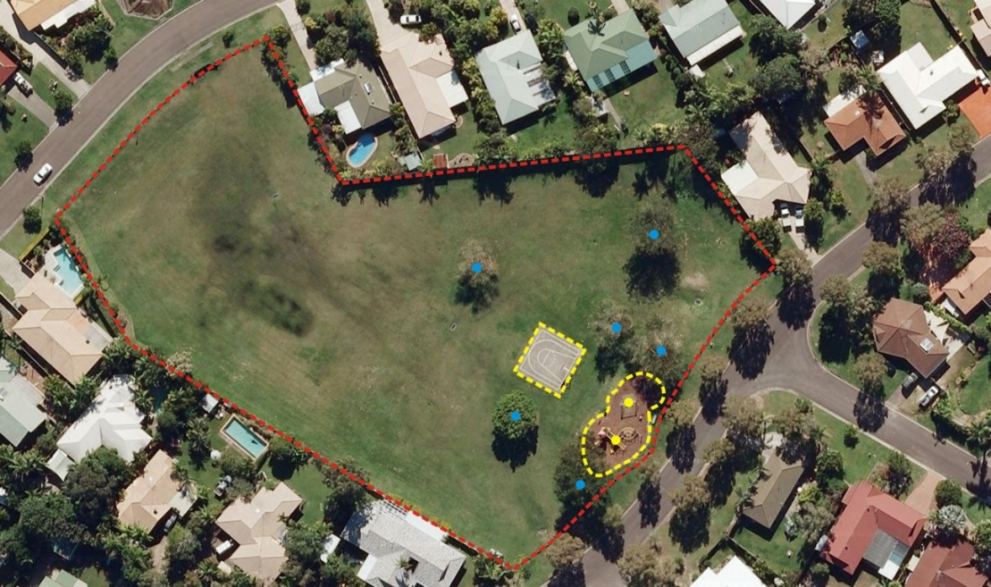Spatial Relationship: These Open Space assets to be totally within the Open Space Area feature.

Figure 1

### BarrierContinuous

Asset Capture: Complex linear feature (read: polylines including curves but not bézier curves) representing a barrier type asset Eg fences, bollards, guardrails, pedestrian fall protection. It is recommended, but not mandatory, that each vertex represents an upright, particularly for bollard runs. This allows the geometry to be exploited to identify the individual features if necessary. Please refer to the dashed yellow line in the example shown below in figure 2.

Spatial Relationship: Open Space Barrier Feature must be within or coincident with the boundary of the Open Space Area feature.

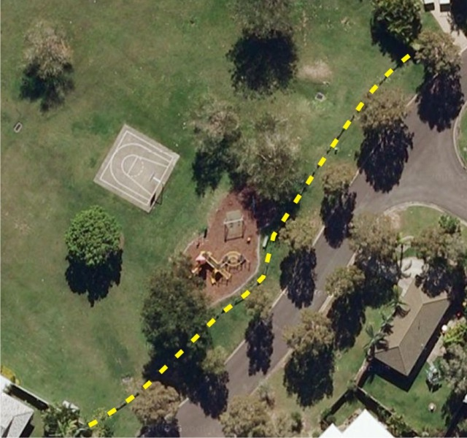

Figure 2

### BoatingFacility

Asset Capture: Area feature representing an individual boating facility such as a pontoon, ramp or jetty.

Spatial Relationship: Not applicable.

### Building

Asset Capture: Area feature (closed polygon) representing the vertical Building footprint for a structure other than a shelter.

Spatial Relationship: Not applicable.

### ElectricalConduit

Asset Capture: Complex linear feature (read: polylines including curves but not bézier curves) representing a conduit run.

Spatial Relationship: Conduit shown as a polyline starting and finishing at coincident points with each associated fitting.

### ElectricalFitting

Asset Capture: Simple point feature representing the centre point of an electrical fitting such as lighting, switch board or power outlet.

Spatial Relationship: Must be coincident to Electrical Conduit polylines.

### LandscapeArea

Asset Capture: Multi-patched area feature representing the “footprint” of a Landscaped area. Individual areas are required where the type of Landscaping changes (e.g. garden beds, enclosed shrubs, physical protection around mature trees etc).

Spatial Relationship: Must be within the Parent Open Space Area feature.

### RetainingWalls

Asset Capture: Complex linear feature (read: polylines including curves but not bézier curves) representing a retaining wall. While recognised as a three dimensional object, the retaining wall is typically captured as a linear course where the wall intersects the ground.

Spatial Relationship: Not applicable.

## Sewerage Assets

### Property Connections

Asset Capture: Complex linear feature (read: polylines including curves but not bézier curves) representing the invert of the pipe asset. Enforced line direction from Inspection Opening to the Non Pressure Pipe/Maintenance Hole due to gravitational flow. Please refer to Figure 3 below.

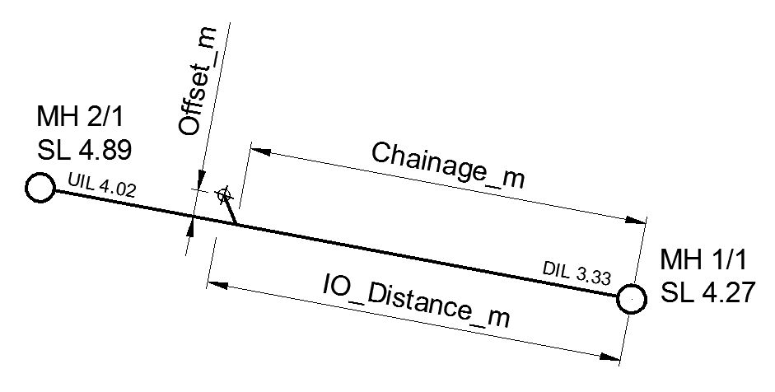Spatial Relationship: Gravity downstream end point of the linear feature must be coincident to anywhere on a Non Pressure pipe linear feature or the point feature of a Maintenance Hole if the asset is a “Stub” connection.

Figure 3

### Fittings

Asset Capture: Single point feature representing the centre point of the fitting.

Spatial Relationship: Must be coincident to the end of pipe assets or a pipe asset anywhere along its length.

### Maintenance Holes (Including Inspection Openings at End-of_Line)

Asset Capture: Single point feature located at the centre of chamber on the top surface. Note: Capturing centre of lid is appropriate only when the lid is centred over the chamber.

Spatial Relationship: Not Applicable.

### Non Pressure Pipes

Asset Capture: Complex linear feature (read: polylines including curves but not Bezier curves) representing the invert of the pipe asset. Enforced line direction from Gravity Upstream (read: higher AHD level) to Gravity Downstream (read: lower AHD level) due to gravitation flow in each individual pipe.

The gravity upstream and downstream ends of an individual pipe are captured at the intersection between the pipe material and the wall of the chamber. Please refer to figure 4 for a detailed diagram. Points 2 and 3 represent the intersection of pipe material and chamber wall whereas points 1 and 4 represent the Maintenance Holes capture.

Spatial Relationship: Not Applicable

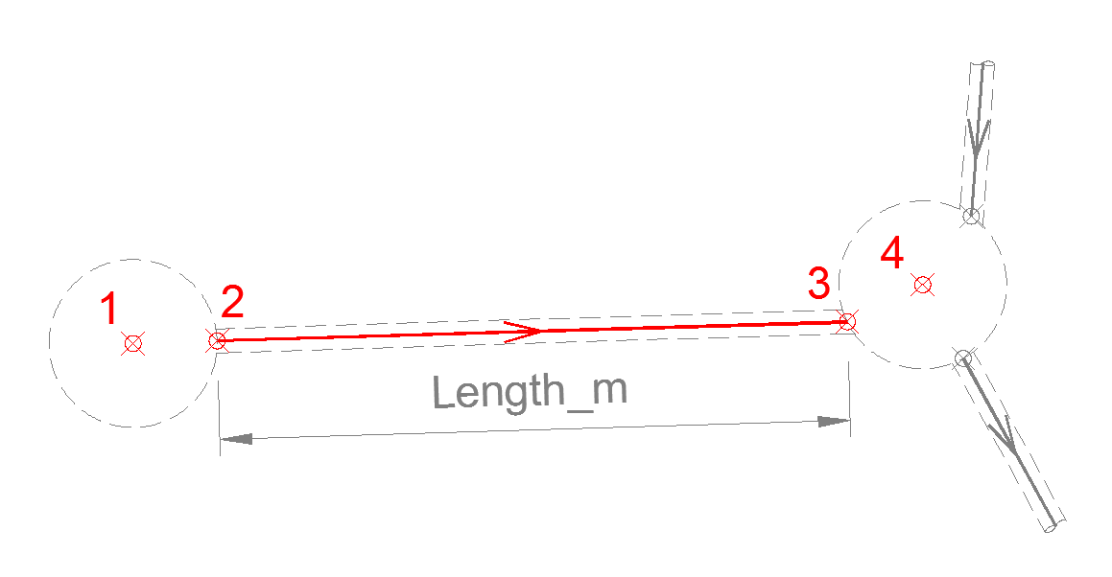

Figure 4

### Pressure Pipes

Asset Capture: Complex linear feature (read: polylines including curves but not Bezier curves) representing the invert of the pipe asset. Enforced line direction from Pump active asset to Discharge Maintenance Hole due to pumped flow.

Pipes to be captured based on their physical and spatial properties and attributes. For example, if a pipe changes size, material, class, embedment or direction etc. then it must be broken and captured separately.

Spatial Relationship: Must be coincident to Pressure pipe point features in the pumped sewerage network.

### Valves

Asset Capture: Single point feature representing the centre of a valve body, typically the spindle.

Spatial Relationship: Must be coincident anywhere along its length or at the end of Pressure Pipe assets.

## StormWater

### EndStructure

Asset Capture: Simple point feature representing the top of the headwall.

Spatial Relationship: Headwall “floats” adjacent to the end of a StormWater pipe feature.

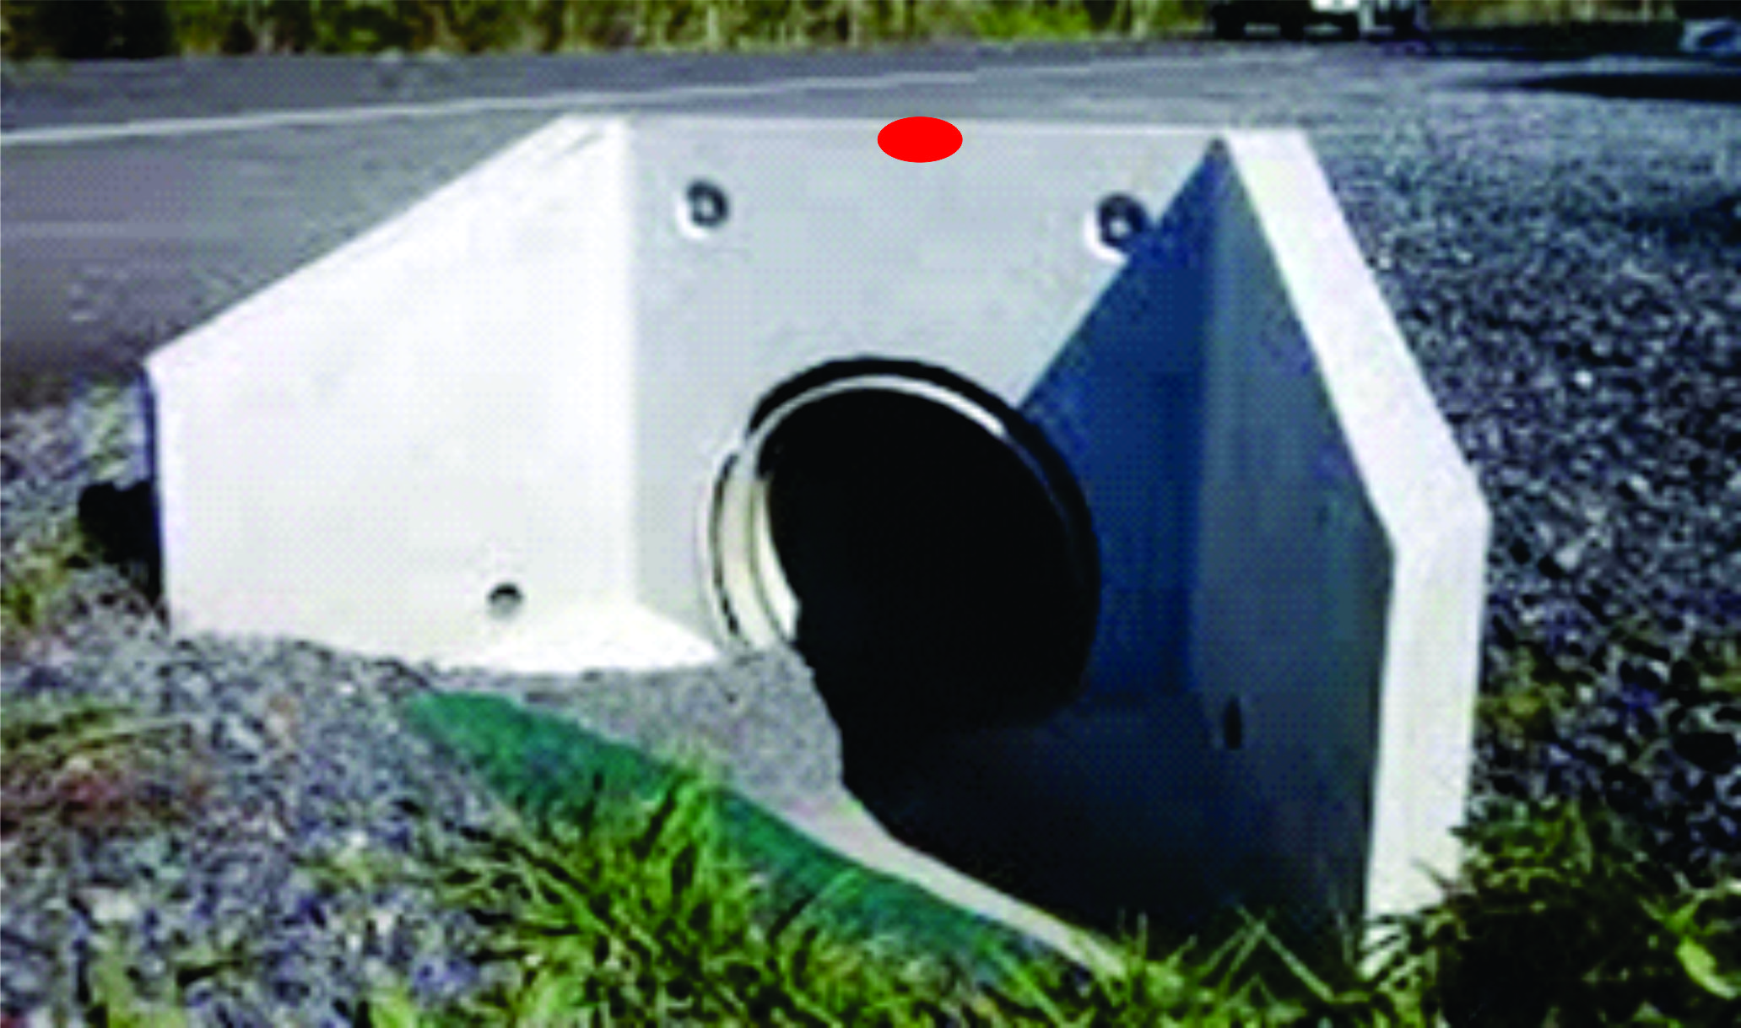

Figure 5

### Fitting

Asset Capture: Single point feature representing the centre point of the fitting. At this stage an End Cap is the only kind of fitting captured in this asset type.

Spatial Relationship: Must be coincident to the end point a StormWater pipe feature.

### GPT Complex / GPT Simple / NonGPTSimple

Asset Capture: Single point feature located at the centre of chamber on the top surface. Note: Capturing centre of lid is appropriate only when the lid is centred over the chamber.

Known as Gross Pollutant Traps (GPTs) fall into and are captured in three primary categories:

- GPT Complex such as Commercial or Custom built device ( e.g. Humes Interceptor)

- GPT Simple such as an “in pit” basket or “end of line” device

- GPT Non-Simple which represent basic and minor sand filtration storage

Spatial Relationship: GPTComplex and NonGPTSimple assets must be coincident to pipe features as per Pits/Manhole features. However GPTSimple asset’s spatial location must correlate with a Pit/Manhole asset as they are housed within those structures and can be removed for maintenance or relocation.

### Pipe

Asset Capture: Simple linear feature representing the invert of the pipe or midpoint of a box asset. One feature represents multiple-celled culverts/pipes, therefore the number of cells is to be recorded in the “Cells” field of the table structure. Enforced line direction from Gravity Upstream (read: higher AHD level) to Gravity Downstream (read: lower AHD level) due to gravitation flow. Pipe features are captured from the intersection of pipe material and chamber wall. Refer to figures 6, 7 and 8 below.

Figure 6 represents a single-celled pipe asset where vertices one and four represent the maintenance hole capture and vertices two and four are the intersection of the Pipe material and the chamber wall.

Figure 7 represents a triple-celled culvert asset from inlet to outlet. In this case there is a spatial relationship between each end of the pipe asset and the End Structure point feature.

Note: Please refer to Receiving Authorities Addendum to these Guidelines where multi-celled pipes are to be represented as individual lines.

Figure 8 represents an irregular shaped pit with multiple multi-celled pipes entering the pit asset and a large single-celled asset exiting the pit and outletting through an End Structure.

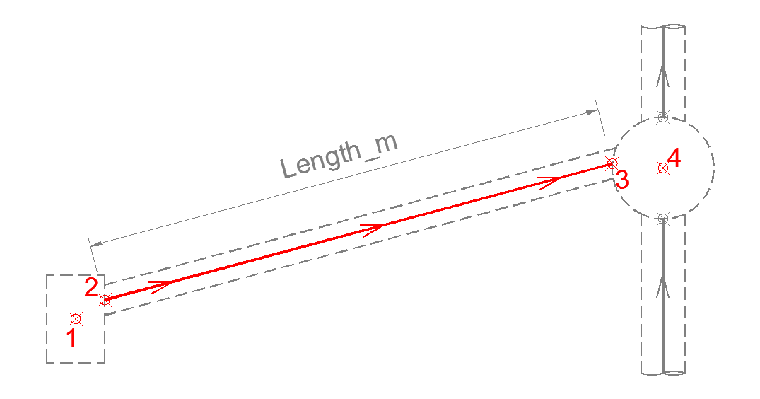Spatial Relationship: May be coincident to StormWater point features.

Figure 6

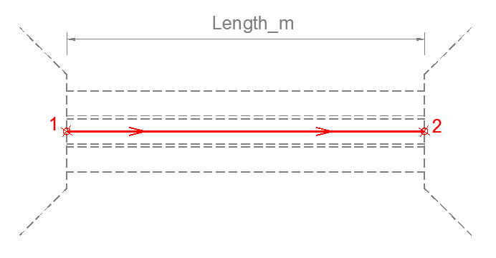

Figure 7

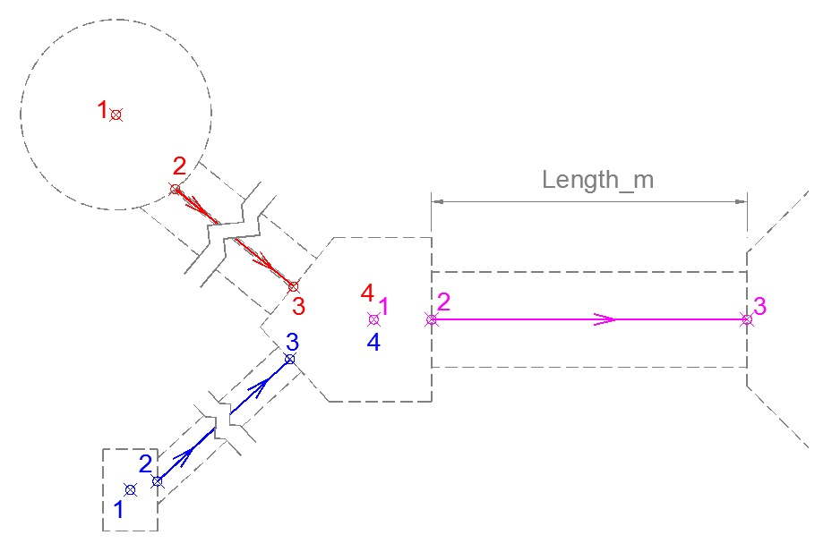

Figure 8

### Pit

Asset Capture: Simple point feature representing the centre of chamber of a pit or manhole. Please note: If the asset’s Use = “Pit” then the InletConfig and InletType elements must be populated. Note: InletConfig’s Left/Centre/Right is referenced from the lintel looking at the road crown.

Spatial Relationship: Not Applicable.

### SurfaceDrain (Including Open Drain)

Asset Capture: Simple linear feature representing the invert of the channel.

Spatial Relationship: May be coincident to EndStructures and WSUD regions/polygons.

### WSUDArea

Asset Capture: Water Sensitive Urban Design areas such as kerbside bio-filtration beds or purpose built drainage swales should be captured individually as a region/polygon. Individual areas are to be recorded within the ADAC data capture fields defining class type (e.g swale, buffer strip, bio-retention basin)

Spatial Relationship: Not Applicable.

## Supplementary

### PointFeature / PolylineFeature / PolygonFeature

Asset Capture: Simple Point, Complex Polyline or Multipatch Area feature (depending on the feature type) representing objects or assets that add clarity or context to the strict ADAC features. Where applicable, please refer to the attached “Addendum to the ADAC Generic Guidelines” for direction regarding Supplementary features.

Spatial Relationship: Not applicable.

## Surface

### Contour

Asset Capture: Linear feature capturing a single contour feature.

Spatial Relationship: Not applicable.

### SpotHeights

Asset Capture: Simple point feature representing a single elevation point.

Spatial Relationship: Not applicable.

## Transport

### FlushPoint

Asset Capture: Simple point feature representing the outlet of Sub-soil drains into Drainage Pits/Maintenance Holes.

Spatial Relationship: Must be coincident to SubSoilDrain assets.

### Pathway / RoadPathway / PathStructure

Asset Capture: Complex linear feature (read: polylines including curves but not Bezier curves) representing the centre longitudinal axis of a pathway. Please refer to the green and red dash/dot line in figure 9 below. The green represents an existing pathway asset whereas the red denotes a newly constructed section of Pathway.

Spatial Relationship: May be coincident to a PramRamp point feature as well as changes in surface types or widths must be coincident points.

### Pavement / Parking

Asset Capture: Multi-patch region/polygon feature representing the area of Pavement. Asset capture is based on physicality therefore separate regions/polygons are required if any part of the pavement profile changes i.e. Surface, Base, Sub-Base, Lower Sub-Base and/or Subgrade. Please refer to the solid blue transparent hatch in figure 9 below for a typical representation of Pavement capture. Also the solid green transparent hatch in figure 10.

Spatial Relationship: Must be coincident to other regions representing pavement / parking where there is a common boundary- no slivers/overlaps.

### PramRamp

Asset Capture: Simple point feature representing a pram ramp. Typically captured in the centre of Pram Ramp where it transitions to a Kerb/Road.

Spatial Relationship: Must be coincident to Pathway, RoadPathway or PathStructure assets.

### RoadEdge

Asset Capture: Complex linear feature (read: polylines including curves but not bézier curves) representing the top of kerb. In case of inverts, edge of concrete furthest from road centreline.

Spatial Relationship: Must be coincident to other polylines representing road edge where there is a common boundary between kerb types / material change i.e. no slivers and/or overlaps.

### RoadIsland

Asset Capture: Multi-patch region/polygon feature representing the area of Island/LATM bounded by the back of Kerb features. Asset capture is based on physicality therefore separate regions/polygons are required if the Type of Island or Infill changes. Please refer to the solid red and purple transparent hatches figure 10 for RoadIsland asset capture.

Spatial Relationship: Must be coincident to other regions representing road islands where there is a common boundary i.e. no slivers and/or overlaps.

### SubSoilDrain

Asset Capture: Simple Linear feature (i.e. straight lines) representing the Invert of a circular sub-soil drain pipe asset. Pipes are typically broken where the Use and/or Type of drain changes.

Spatial Relationship: Must be coincident to Flush points.

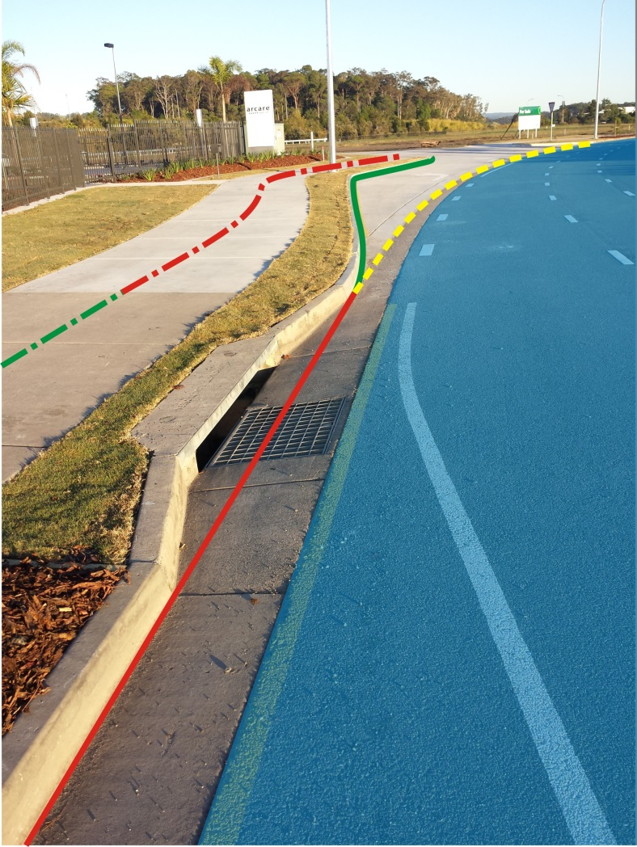

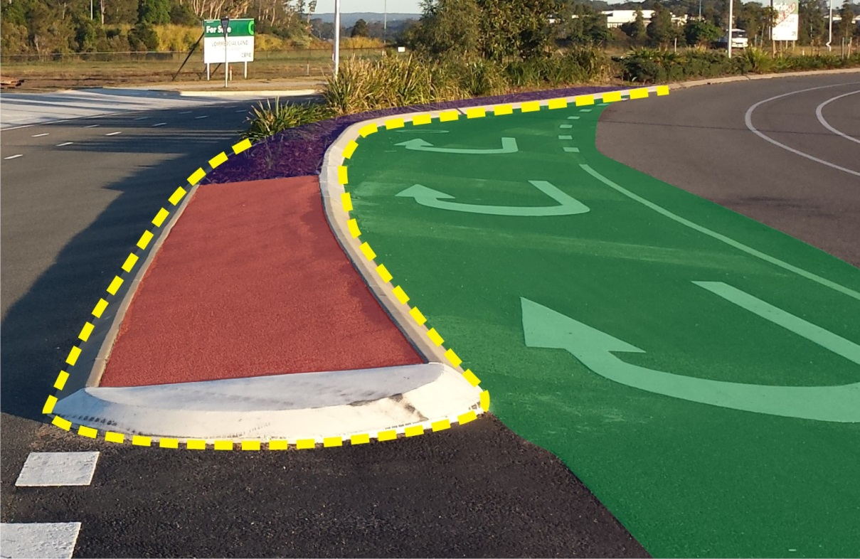 Figure 9

Figure 10

## Water Supply Assets

### Fittings / Service Fittings / Irrigation Fittings

Asset Capture: Single point feature representing the centre point of the fitting. Please refer to the yellow circles in figure 11 below for representations of a Tee and Tapping Band.

Spatial Relationship: Must be coincident to a pipe asset in the water reticulation network.

### Hydrants

Asset Capture: Single point feature representing the centre of the vertical hydrant branch.

Spatial Relationship: Must be coincident to a pipe asset.

### Maintenance Holes / Storage Tanks

Asset Capture: Single point feature located on the centre of the chamber. If required to capture the polygon feature please utilise the Supplementary Polygon feature (refer to Supplementary Features page 17 above).

Spatial Relationship: No connectivity is enforced due to the size and shape of the object.

### Meters

Asset Capture: Single point feature located at the centre point of the domestic meter itself.

Please note: The definition for the OffsetSide element is “ the offset from the left or the right side boundary when looking from the road.”

Spatial Relationship: Must be coincident to a water pipe with a Use of “Fire Service”, “Service” or “Fire Service Thru Meter”.

### Pipes

Asset Capture: Simple Linear feature (i.e. straight lines) representing the Invert of a circular pipe asset. Pipe segments are to be captured based on the pipe attributes. If any physical element of a pipe changes (e.g. size, material, class etc.) then the pipe asset must be broken and captured separately. Please refer to the red and green polylines in figure 11 below. The red lines represent reticulation pipes whereas the green line represents a service pipe. Note: the dash/dot polyline is not broken at the fittings as the physical specification of the pipe doesn’t change.

Spatial Relationship: Pipes must be coincident to water valves and fittings that participate in a flow network.

### Valves

Asset Capture: Single point feature representing the centre of a valve body, typically the spindle.

Spatial Relationship: Must be coincident to a Water Pipe asset.

Below is an image of a Tee and Tapping Band (yellow circles) connected to reticulation mains (redlines) and a service pipe (green line).

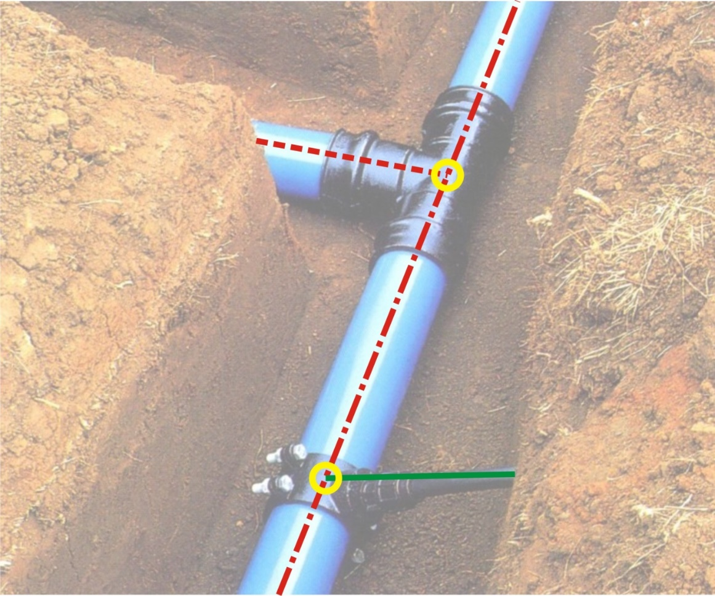

Figure 11

# 

# APPENDIX A - ADAC DATA SCHEMA

The following hierarchy identifies the individual asset types, attributes available to be captured and the mandatory status of said attributes.

## Global Object Model

All assets gain the following:

|  |  |
| --- | --- |
| **Element Name** | **Mandatory (Y/N)** |
| ObjectId | N |
| InfrastructureCode | N |
| Owner | N |
| Status | Y |
| Notes | N |
| SupportingFile() * | N |

* Brackets denote an “array”, used to specify a variable(s) that can be indexed

## Cadastre Object Model

**Connection**

|  |  |
| --- | --- |
| **Element Name** | **Mandatory (Y/N)** |
| Bearing | Y |
| Distance_m | Y |

**Easement**

|  |  |
| --- | --- |
| **Element Name** | **Mandatory (Y/N)** |
| LotNo | Y |
| PlanNo | Y |

**Lot**

|  |  |
| --- | --- |
| **Element Name** | **Mandatory (Y/N)** |
| LotNo | Y |
| PlanNo | Y |
| CancelledLotPlan | N |
| TitledArea_sqm | Y |

**RoadReserve**

|  |  |
| --- | --- |
| **Element Name** | **Mandatory (Y/N)** |
| Name | Y |

**SurveyMark**

|  |  |
| --- | --- |
| **Element Name** | **Mandatory (Y/N)** |
| MarkName | Y |

**WaterCourseReserve**

|  |  |
| --- | --- |
| **Element Name** | **Mandatory (Y/N)** |
| Name | Y |

## OpenSpace Object Model

**ActivityArea**

|  |  |
| --- | --- |
| **Element Name** | **Mandatory (Y/N)** |
| Use | Y |
| Type | Y |
| UnderSurfaceMaterial | Y |
| EdgeType | Y |

**ActivityPoint**

|  |  |
| --- | --- |
| **Element Name** | **Mandatory (Y/N)** |
| Use | Y |
| Type | Y |
| Material | Y |
| Theme | N |
| Units | N |
| Manufacturer | N |
| ModelNumber | N |

**Artwork**

|  |  |
| --- | --- |
| **Element Name** | **Mandatory (Y/N)** |
| Type | Y |
| Material | Y |

**BarrierContinuous**

|  |  |
| --- | --- |
| **Element Name** | **Mandatory (Y/N)** |
| Type | Y |
| UprightMaterial | Y |
| LinkMaterial | Y |
| TopMaterial | Y |
| Length_m | Y |
| Height_m | Y |
| UprightNumber | Y |

**BarrierPoint**

|  |  |
| --- | --- |
| **Element Name** | **Mandatory (Y/N)** |
| Type | Y |
| UprightMaterial | Y |

**BBQ**

|  |  |
| --- | --- |
| **Element Name** | **Mandatory (Y/N)** |
| EnergySource | Y |
| Plates | Y |
| SurroundingMaterial | Y |
| TopMaterial | Y |
| Manufacturer | N |
| ModelNumber | N |

**BicycleFitting**

|  |  |
| --- | --- |
| **Element Name** | **Mandatory (Y/N)** |
| Type | Y |
| Material | Y |
| Manufacturer | N |
| ModelNumber | N |

**Boating Facility**

|  |  |
| --- | --- |
| **Element Name** | **Mandatory (Y/N)** |
| Type | Y |
| Material | Y |

**Building**

|  |  |
| --- | --- |
| **Element Name** | **Mandatory (Y/N)** |
| Type | Y |
| Material | Y |

**ElectricalConduit**

|  |  |
| --- | --- |
| **Element Name** | **Mandatory (Y/N)** |
| Type | Y |
| Material | Y |
| Diameter_mm | Y |
| Length_m | Y |
| Protection | N |

**ElectricalFitting**

|  |  |
| --- | --- |
| **Element Name** | **Mandatory (Y/N)** |
| Type | Y |
| Base | Y |
| Material | Y |
| EnergySource | Y |
| Manufacturer | N |
| ModelNumber | N |

**Fixture**

|  |  |
| --- | --- |
| **Element Name** | **Mandatory (Y/N)** |
| Type | Y |
| Material | Y |
| Manufacturer | N |
| ModelNumber | N |

**LandscapeArea**

|  |  |
| --- | --- |
| **Element Name** | **Mandatory (Y/N)** |
| Type | Y |
| EdgeMaterial | Y |
| RootBarrier | Y |

**OpenSpaceArea**

|  |  |
| --- | --- |
| **Element Name** | **Mandatory (Y/N)** |
| Name | Y |
| Type | Y |

**RetainingWall**

|  |  |
| --- | --- |
| **Element Name** | **Mandatory (Y/N)** |
| Use | Y |
| Material | Y |
| Construction | Y |
| Length_m | Y |
| Height_m | Y |

**Seat**

|  |  |
| --- | --- |
| **Element Name** | **Mandatory (Y/N)** |
| SeatType | Y |
| Places | Y |
| Material | Y |
| Manufacturer | N |
| ModelNumber | N |

**Shelter**

|  |  |
| --- | --- |
| **Element Name** | **Mandatory (Y/N)** |
| Type | Y |
| ConstructionType | Y |
| FloorMaterial | Y |
| WallMaterial | Y |
| RoofMaterial | Y |
| Manufacturer | N |
| ModelNumber | N |

**Sign**

|  |  |
| --- | --- |
| **Element Name** | **Mandatory (Y/N)** |
| Type | Y |
| Material | Y |
| Manufacturer | N |
| ModelNumber | N |
| Structure | Y |
| SignText | N |
| Rotation | N |

**Table**

|  |  |
| --- | --- |
| **Element Name** | **Mandatory (Y/N)** |
| Type | Y |
| SeatType | Y (if seating exists) |
| Places | Y (if seating exists) |
| Material | Y |
| Manufacturer | N |
| ModelNumber | N |

**Tree**

|  |  |
| --- | --- |
| **Element Name** | **Mandatory (Y/N)** |
| Species | Y |
| Genus | Y |
| RootBarrier | Y |
| Grate | Y |

**WasteCollectionPoint**

|  |  |
| --- | --- |
| **Element Name** | **Mandatory (Y/N)** |
| Type | Y |
| Material | Y |
| Manufacturer | N |
| ModelNumber | N |

## Sewerage Object Model

**Connection**

|  |  |
| --- | --- |
| **Element Name** | **Mandatory (Y/N)** |
| SurfaceLevel_m | Y |
| InvertLevel_m | Y |
| Use | Y |
| Diameter_mm | Y |
| Material | Y |
| Class | Y |
| Length_m | Y |
| Type | Y |
| Chainage_m | Y |
| Offset_m | Y |
| LineNumber | N |
| DSMHID | N |
| IO_Distance_m | Y |
| SO_Nearest_m | Y |
| SO_Other_m | Y |
| Sediment_Trap | Y |

**Fitting**

|  |  |
| --- | --- |
| **Element Name** | **Mandatory (Y/N)** |
| Type | Y |
| Material | Y |
| BodySize_mm | Y |
| BranchSize_mm | N |
| Rotation | N |

**MaintenanceHole**

|  |  |
| --- | --- |
| **Element Name** | **Mandatory (Y/N)** |
| Use | Y |
| Length_mm | Y (Rectangular only) |
| Width_mm | Y (Rectangular only) |
| Diameter_mm | Y (Circular only) |
| Area_sqm | Y (Custom only) |
| SurfaceLevel_m | Y |
| InvertLevel_m | Y |
| FloorConstruction | Y |
| FloorMaterial | Y |
| WallConstruction | Y |
| WallMaterial | Y |
| RoofMaterial | Y |
| Lining | N |
| LidMaterial | Y |
| DropType | Y |
| CatchmentPS | N |
| LineNumber | N |
| MH_Number | Y |
| Chainage_m | N |
| TieDistance_m | N |
| OffsetDistance_m | N |
| Rotation | Y |

**PipeNonPressure**

|  |  |
| --- | --- |
| **Element Name** | **Mandatory (Y/N)** |
| LineNumber | N |
| Use | Y |
| Diameter_mm | Y |
| Material | Y |
| Class | Y |
| Lining | N |
| Protection | Y |
| JointType | Y |
| US_InvertLevel_m | Y |
| DS_InvertLevel_m | Y |
| US_SurfaceLevel_m | Y |
| DS_SurfaceLevel_m | Y |
| Alignment_m | N |
| AverageDepth_m | Y |
| Embedment | Y |
| RockExcavated | N |
| PipeGrade | N |
| Length_m | N |

**PipePressure**

|  |  |
| --- | --- |
| **Element Name** | **Mandatory (Y/N)** |
| Use | Y |
| Diameter_mm | Y |
| Material | Y |
| Class | Y |
| Lining | N |
| Protection | N |
| JointType | Y |
| Alignment_m | N |
| AverageDepth_m | N |
| Embedment | N |
| RockExcavated | N |
| Length_m | N |

**Valve**

|  |  |
| --- | --- |
| **Element Name** | **Mandatory (Y/N)** |
| Use | Y |
| Type | Y |
| Diameter_mm | Y |
| Protection | N |
| Manufacturer | N |
| ModelNumber | N |
| Rotation | N |

## Stormwater Object Model

**EndStructure**

|  |  |
| --- | --- |
| **Element Name** | **Mandatory (Y/N)** |
| StructureID | Y |
| StructureLevel_m | Y |
| EndWallType | Y (if EndWall exists) |
| EndWallConstruction | Y (if EndWall exists) |
| WingWallType | Y (if WingWall exists) |
| WingWallConstruction | Y (if WingWall exists) |
| ApronType | Y (if Apron exists) |
| ApronConstruction | Y (if Apron exists) |
| GrateType | N |
| TideGate | N |
| PredominantMaterial | Y |
| OutletProtectionType | Y |
| Rotation | N |

**Fitting**

|  |  |
| --- | --- |
| **Element Name** | **Mandatory (Y/N)** |
| FittingType | Y |
| Rotation | N |

**GPTComplex**

|  |  |
| --- | --- |
| **Element Name** | **Mandatory (Y/N)** |
| Sqid_Id | N |
| Manufacturer | Y (if Commerical) |
| ModelNumber | Y (if Commerical) |
| Length_mm | Y (Rectangular only) |
| Width_mm | Y (Rectangular only) |
| Diameter_mm | Y (Circular only) |
| Function1 | Y |
| Function2 | N |
| Function3 | N |
| US_PipeDiameter_mm | N |
| DS_PipeDiameter_mm | N |
| SurfaceLevel_m | Y |
| US_InvertLevel_m | Y |
| DS_InvertLevel_m | Y |
| CleanoutLevel_m | Y |
| Depth_m | N |
| SumpDepth_m | N |
| HasFilterMedia | N |
| HasBasket | N |
| HasBoards | N |
| DesignFlow_m3s | Y |
| MaxContaminantVolume_m3 | N |
| MaxInternalVolume_m3 | N |
| MaintenanceCycle_mnths | N |
| Rotation | N |

**GPTSimple**

|  |  |
| --- | --- |
| **Element Name** | **Mandatory (Y/N)** |
| Sqid_Id | N |
| Construction | Y |
| Manufacturer | N |
| ModelNumber | N |
| TreatmentMeasure | Y |
| Function1 | Y |
| Length_mm | Y |
| Width_mm | N |
| MaintenanceCycle_mnths | N |
| Rotation | N |

**NonGPTSimple**

|  |  |
| --- | --- |
| **Element Name** | **Mandatory (Y/N)** |
| Sqid_Id | N |
| Construction | Y |
| Manufacturer | N |
| ModelNumber | N |
| TreatmentMeasure | Y |
| Function1 | Y |
| Function2 | N |
| Function3 | N |
| Length_mm | Y |
| Width_mm | N |
| MaintenanceCycle_mnths | N |
| Rotation | N |

**Pipe**

|  |  |
| --- | --- |
| **Element Name** | **Mandatory (Y/N)** |
| US_InvertLevel_m | Y |
| DS_InvertLevel_m | Y |
| US_SurfaceLevel_m | Y |
| DS_SurfaceLevel_m | Y |
| Diameter_mm | Y (Circular only) |
| Height_mm | Y (Rectangular only) |
| Width_mm | Y (Rectangular only) |
| Material | Y |
| Class | Y |
| JointType | Y (Circular only) |
| Cells | Y |
| ConcreteCoverType | Y |
| Grade | N |
| Length_m | N |

**Pit**

|  |  |
| --- | --- |
| **Element Name** | **Mandatory (Y/N)** |
| PitNumber | Y |
| Use | Y |
| ChamberConstruction | Y |
| Length_mm | Y (Rectangular only) |
| Width_mm | Y (Rectangular only) |
| Diameter_mm | Y (Circular only) |
| Radius_mm | Y (Extended only) |
| Extension_mm | Y (Extended only) |
| LidType | N |
| SurfaceLevel_m | Y |
| InvertLevel_m | Y |
| Depth_m | Y |
| InletConfig | Y (if Inlet exists) |
| InletType | Y (if Inlet exists) |
| LintelConstruction | Y (if Lintel exists) |
| LintelLength_m | Y (if Lintel exists) |
| OutletType | Y |
| FireRetardant | Y |
| Rotation | N |

**SurfaceDrain**

|  |  |
| --- | --- |
| **Element Name** | **Mandatory (Y/N)** |
| Type | Y |
| Shape | Y |
| LiningMaterial | Y |
| LinedWidth_m | Y |
| BatterMaterial | N |
| BatterWidth_m | N |
| US_InvertLevel_m | Y |
| DS_InvertLevel_m | Y |
| AverageGrade | N |
| Length_m | N |

**WSUDArea**

|  |  |
| --- | --- |
| **Element Name** | **Mandatory (Y/N)** |
| Sqid_Id | N |
| TreatmentMeasure | Y |
| Function1 | Y |
| Function2 | N |
| Function3 | N |
| PondingArea_m2 | N |
| PondingDepth_m | N |
| FilterArea_m2 | N |
| FilterDepth_m | N |
| TransitionDepth_m | N |
| DrainageDepth_m | N |
| MacrophyteZoneArea_m2 | N |
| MacrophyteZoneDepth_m | N |
| CoarseSedimentArea_m2 | N |
| SedimentVolume_m3 | N |
| MinSurfaceLevel_m | N |
| PermanentPondLevel_m | N |
| OutletLevel_m | N |
| DesignFlow_m3s | N |
| HasSpillway | Y |
| MaintenanceCycle_mnths | N |

## Supplementary Object Model

Note: These features only contain the Object_Id element from the Global elements.

**SupplementaryPoint / SupplementaryPolyline / SupplementaryPolygon**

|  |  |
| --- | --- |
| **Element Name** | **Mandatory (Y/N)** |
| Class | Y |
| Note | N |
| Attribute()TextValue | N |
| Attribute()IntegerValue | N |
| Attribute()DecimalValue | N |
| Attribute()DateValue | N |
| Attribute()TimeValue | N |
| Attribute()DateTimeValue | N |

## Surface Object Model

Note: These features only contain the Object_Id element from the Global elements.

**Contour / SpotHeight**

|  |  |
| --- | --- |
| **Element Name** | **Mandatory (Y/N)** |
| Status | Y |
| Elevation_m | Y |

## Transport Object Model

**FlushPoint**

|  |  |
| --- | --- |
| **Element Name** | **Mandatory (Y/N)** |
| Function | Y |

**Parking**

|  |  |
| --- | --- |
| **Element Name** | **Mandatory (Y/N)** |
| Name | Y |
| NoOfCarparks | N |
| OnOffStreet | Y |
| SurfaceType | Y (if Surface exists) |
| SurfaceThickness_mm | Y (if Surface exists) |
| SurfaceArea_sqm | N |
| PavementType | Y |
| BaseLayerType | Y (If BaseLayer exists) |
| BaseLayerDepth_mm | Y (If BaseLayer exists) |
| BaseStabilisation | N |
| SubBaseLayerType | Y (If SubBaseLayer exists) |
| SubBaseLayerDepth_mm | Y (If SubBaseLayer exists) |
| SubBaseStabilisation | N |
| LowerSubBaseLayerType | Y (If LowerSubBaseLayer exists) |
| LowerSubBaseLayerDepth_mm | Y (If LowerSubBaseLayer exists) |
| LowerSubBaseStabilisation | N |
| PavementGeoTextile | N |
| SubgradeCBR | Y |
| SubgradeStabilisation | N |

**PathStructure**

|  |  |
| --- | --- |
| **Element Name** | **Mandatory (Y/N)** |
| Use | Y |
| Structure | Y |
| SurfaceMaterial | Y |
| SubStructureMaterial | Y |
| Width_m | Y |

**Pathway**

|  |  |
| --- | --- |
| **Element Name** | **Mandatory (Y/N)** |
| Use | Y |
| Structure | Y |
| SurfaceMaterial | Y |
| Width_m | Y |
| Depth_mm | Y |

**Pavement**

|  |  |
| --- | --- |
| **Element Name** | **Mandatory (Y/N)** |
| Name | Y |
| SurfaceType | Y (if Surface exists) |
| SurfaceThickness_mm | N |
| SurfaceNomWidth_m | Y (if Surface exists) |
| PavementType | Y |
| BaseLayerType | Y (If BaseLayer exists) |
| BaseLayerDepth_mm | Y (If BaseLayer exists) |
| BaseStabilisation | N |
| SubBaseLayerType | Y (If SubBaseLayer exists) |
| SubBaseLayerDepth_mm | Y (If SubBaseLayer exists) |
| SubBaseStabilisation | N |
| LowerSubBaseLayerType | Y (If LowerSubBaseLayer exists) |
| LowerSubBaseLayerDepth_mm | Y (If LowerSubBaseLayer exists) |
| LowerSubBaseStabilisation | N |
| PavementGeoTextile | N |
| SubgradeCBR | Y |
| SubgradeStabilisation | N |

**PramRamp**

|  |  |
| --- | --- |
| **Element Name** | **Mandatory (Y/N)** |
| Rotation | N |

**RoadEdge**

|  |  |
| --- | --- |
| **Element Name** | **Mandatory (Y/N)** |
| Type | Y |
| Length_m | N |
| PavementExtension_mm | Y |

**RoadIsland**

|  |  |
| --- | --- |
| **Element Name** | **Mandatory (Y/N)** |
| Type | Y |
| Area_sqm | N |
| InfillType | Y |

**RoadPathway**

|  |  |
| --- | --- |
| **Element Name** | **Mandatory (Y/N)** |
| Use | Y |
| Structure | Y |
| SurfaceMaterial | Y |
| Width_m | Y |

**SubSoilDrain**

|  |  |
| --- | --- |
| **Element Name** | **Mandatory (Y/N)** |
| Use | Y |
| Type | Y |
| Length_m | N |

## Water Supply Object Model

**Fitting**

|  |  |
| --- | --- |
| **Element Name** | **Mandatory (Y/N)** |
| Type | Y |
| Material | Y |
| Lining | N |
| Protection | N |
| BodySize_mm | Y |
| BranchSize_mm | N |
| Rotation | N |

**Hydrant**

|  |  |
| --- | --- |
| **Element Name** | **Mandatory (Y/N)** |
| Use | Y |
| Diameter_mm | Y |
| Rotation | N |

**IrrigationFitting**

|  |  |
| --- | --- |
| **Element Name** | **Mandatory (Y/N)** |
| Type | Y |
| BelowGround | Y |
| Rotation | N |

**MaintenanceHole**

|  |  |
| --- | --- |
| **Element Name** | **Mandatory (Y/N)** |
| Use | Y |
| Length_mm | Y (Rectangular only) |
| Width_mm | Y (Rectangular only) |
| Diameter_mm | Y (Circular only) |
| SurfaceLevel_m | Y |
| InvertLevel_m | Y |
| FloorConstruction | Y |
| FloorMaterial | Y |
| WallConstruction | Y |
| WallMaterial | Y |
| RoofMaterial | Y |
| LidMaterial | Y |
| Rotation | N |

**Meter**

|  |  |
| --- | --- |
| **Element Name** | **Mandatory (Y/N)** |
| SerialNumber | Y |
| Type | Y |
| Diameter_mm | Y |
| Dials | N |
| Manufacturer | N |
| ModelNumber | N |
| InitialReading | N |
| PrivateBooster | Y |
| Offset_m | Y |
| InstallationDate | Y |
| LotNo | Y |
| PlanNo | Y |
| Rotation | N |

**Pipe**

|  |  |
| --- | --- |
| **Element Name** | **Mandatory (Y/N)** |
| Use | Y |
| Alignment_m | N |
| Diameter_mm | Y |
| Material | Y |
| Class | Y |
| Lining | N |
| Protection | N |
| JointType | N |
| AverageDepth_m | N |
| Embedment | N |
| Length_m | N |

**ServiceFitting**

|  |  |
| --- | --- |
| **Element Name** | **Mandatory (Y/N)** |
| Type | Y |
| BelowGround | Y |
| WaterSaver | Y |
| AutoShutOff | Y |
| Rotation | N |

**StorageTank**

|  |  |
| --- | --- |
| **Element Name** | **Mandatory (Y/N)** |
| Material | Y |
| Source | Y |
| Manufacturer | N |
| ModelNumber | N |
| Volume_m3 | Y |
| Rotation | N |

**Valve**

|  |  |
| --- | --- |
| **Element Name** | **Mandatory (Y/N)** |
| Use | Y |
| Type | Y |
| Diameter_mm | Y |
| Manufacturer | N |
| ModelNumber | N |
| Rotation | N |

1. Various software tools (purpose-built ADAC XML generators) are available to capture necessary details and asset attributes required to produce a compliant ADAC XML file. Advice on the choice and application of the products available can be sort from providers of most software design suites and survey tools.
2. Intergovernmental Committee on Surveying & Mapping - [www.icsm.gov.au](http://www.icsm.gov.au)