
FOOD ESSENTIALS
ESSENTIALS
FOOD ESSENTIALS
Match the words

- Two hour / four hour guide | - The transfer of harmful bacteria or viruses from one food to another. Harmful bacteria or viruses can also be transferred to food from another source, such as hands or dirty surfaces or utensils.
- Personal hygiene | b. Food that contains harmful bacteria, viruses, foreign matter or chemicals.
- Cross contamination | c. Foods that can become unsafe if not refrigerated under 5⁰C or held above 60⁰C. For example many precooked dishes such as rice, lasagne and casseroles.
- Potentially hazardous food | d. Provides a way of monitoring the time that potentially hazardous food spends in the temperature danger zone of 5°C to 60°C to limit the risk of it becoming unsafe.
- Contaminated food | e. Cleanliness, keeping yourself clean. Wash your hands before touching or eating food; after touching raw meat, fish, chicken or unwashed vegetables; after using the toilet; after blowing your nose; after touching a pet.

Enforcement strategy
The promotion of food safety, including assisting food premises handle food safely, remains a key priority for Rockhampton Regional Council.
To complement this educative approach, the Food Act 2006 provides Council with a range of enforcement options, including the ability to issue improvement notices and infringement notices for certain non-compliances.

Infringement notices
Council is able to issue infringement notices for offences including:
- Failure to store, process, display and transport food,
- Lack of cleanliness and adequacy of food premises,
- Failure to clean and sanitise food equipment,
- Operating a food premises without a food business licence,
- Non-compliance with an improvement notice

Penalties
Penalties, or fines, for infringements are expressed in terms of penalty units. Penalty units are set in the State Penalty and Enforcement Act 1999.

The current value of one penalty unit is $113.85. For example If an offence has 200 penalty units the amount of the infringement is
$22 770.
In this issue…
- Egg safety
- Gluten-free kitchens
- Mobile food business register
- Bug zappers
- Lighting requirements
- Food safety in emergency situations: Power failure
- Ice machines
- Can opener contamination
- Appropriate skills and knowledge
- Myth or fact: Food borne illness
- Match the words
- Food safety websites
- Enforcement strategy
Renewal of Food Business Licence
Ensure your Food Business Licence is renewed by 30 June 2015. Food businesses that do not renew their licence by 30 June 2015 will face financial and possible legal consequences.
Have you made any changes?
Making structural changes to your food premise may require an amendment to your food business licence.
If you are planning to renovate please ensure you discuss your proposal with an Environmental Health Officer to determine if an application is required.
Any renovation must comply with the Food Safety Standards.
Egg safety

There has been an unprecedented increase in cases of food borne illness, many of which related to outbreaks of Salmonella. Of these outbreaks, raw eggs were used as an ingredient in foods that were not cooked further or not cooked for long enough. The following precautions should be taken when handling eggs:
- Avoiding unnecessary handling of eggs,
- Hands should be washed and dried before and after handling eggs,
- Contact between the shell and the contents of the egg should be minimised when breaking eggs,
- Ensure utensils, equipment and other food contact surfaces such as benches are appropriately cleaned and sanitised after handling eggs and egg products,
- Never use cracked or dirty eggs in the preparation of food,
- Store egg and egg products under refrigeration,
- A clean separate container should be used for each batch of an egg product,
- Don’t wash eggs- egg shells become more porous when wet allowing bacteria on the shell to get inside the egg.

Tips for establishing gluten-free kitchens

Offering a gluten-free menu can be a valuable service, but before this can be implemented, it is important to make sure there are procedures incorporated into the food business to ensure that food is prepared safely. Following these tips will assist food businesses to safely provide a gluten-free menu:
- Identify gluten-containing ingredients in your kitchen and isolate,
- Dedicate equipment to be used for gluten-free menu items and keep the kitchen sanitised at all times,
- Educate staff on what they need to do while preparing gluten-free food.

For more information contact Council
1300 22 55 77 | www.rrc.qld.gov.au
4932 9000 or 1300 22 55 77 | www.rrc.qld.gov.au
Rockhampton Regional Council | Environment & Public Health | Food Safety Newsletter | Issue 4
Food safety websites
Please see below for some useful websites on food safety and regulation of food businesses:
- Queensland Health: - www.health.qld.gov.au
- Food Standards Australia & New Zealand: -
www.foodstandards.gov.au
- Safe Food Queensland: - www.safefood.qld.gov.au
- Food Safety Information Council: - www.foodsafety.asn.au
- I’m Alert Food Safety: - www.imalert.com.au

- I’m Alert Food Safety: - www.imalert.com.au

Mobile food business register

A mobile food premises is a vehicle from which a person sells unpackaged food by retail. This does not include a food transport vehicle that is only used to transport food for a business for off-site catering or a food delivery vehicle. A food business operating from mobile premises is only required to have a food business licence in one of the Queensland local governments within which they intend to operate. The register of mobile food businesses (www.health.qld.gov.au/foodsafety/consumers/mobile_premises) contains the details of each mobile food business such as; the name of the local government that issued the licence, the licensee’s name and contact details, licence number, the expiry date of the licence, a description of the premises, including the registration number if the premises are a vehicle that is required to be registered with Queensland Transport.
Bug zappers

Insect control devices (‘zappers’) can be installed in kitchens but must not be located directly over food preparation or storage areas, exposed food, clean equipment or unwrapped packaging material. Insect control devices must be able to capture and hold all insects within the device and be cleaned regularly.

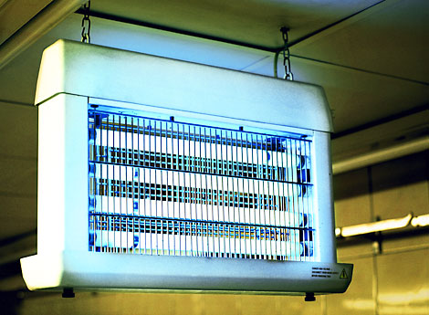

Lighting requirements

Lights must be designed and constructed to prevent the contamination of food should the globe or tube shatter. This can be achieved by providing a shatterproof cover over the globe. The level of light over food preparation surfaces in food premises needs to be a minimum of 500 Lux.

Light fittings are to be free from any features that would harbour dirt, dust or insects or make the fitting difficult to clean.

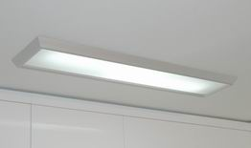

Can opener contamination

Bench mounted can openers are often used to open canned food products easily and efficiently with relatively low risk to the operator.

Bench mounted can openers are often overlooked when it comes to cleaning and sanitising.

On many occasions can openers have been seen with a build-up of food matter and/or metal fillings. Each time the unclean can opener is used, the food product has been exposed to contamination.

Blades need to be cleaned then sanitised after each use, and replaced when worn or damaged.

Educate your staff on the use and cleaning and sanitising process of the can opener to ensure there is no risk to food safety.

Cardboard and Al foil

Food safety in emergency situations - Power failure

In the event of power failure it is your responsibility to keep high-risk foods safe until power is restored:
- Try to keep cold and frozen food cold. If food is less than 5°C, it is safe to use,
- Place an insulating food cover over cold or frozen food where possible.
- If available, put bagged ice under food packages and trays stored in freezers and fridges if power failure lasts more than one hour,
- Serve hot food within four hours of it being hot (above 60°C) or throw it away,

After a power failure:
- Cold or frozen food that reaches, 5°C or above, can be kept and eaten for up to four hours and then it must be thrown away or, if it is raw meat, it should be cooked and eaten and
- Food that was frozen and is still solid is safe to refreeze.

is served to customers is considered food and

Ice needs to be treated like any other food product. This
includes proper ice machine care, ice handling and old ice
disposal.

Clean your ice machine

A regular commercial ice machine maintenance and cleaning schedule is required to combat mineral deposits and slime build-up inside the machine. When commercial ice machines are not properly maintained both overall performance and ice quality suffer.

Do’s | Don’ts
- Make sure employees wash their hands before and after working with ice.  - Use a dedicated food grade container for transporting ice.  - Store the cleaned and sanitised ice scoop outside of the ice storage bin .  - Sanitise your ice bin regularly. | - Handle or scoop ice by hand.  - Use ice buckets or glasses as scoops.  - Store bottles or other products in food grade ice.  - Place unused ice back into the ice bin.

Food Safety Newsletter | Issue 4
Food Safety Newsletter | Issue 4
Appropriate skills and knowledge

The Food Safety Standards requires food businesses to ensure persons supervising or handling food have appropriate skills and knowledge in food safety and food hygiene matters.

Food businesses can decide how their staff obtain the appropriate skills and knowledge. Different approaches include:

- Providing in-house food safety and hygiene training,
- Providing relevant food safety documentation for staff to read,
- Having suitable operating procedures in place,
- Getting food handlers to undergo the free I’m Alert online training, available on Council’s website,
- Hiring a consultant to run food safety training for staff.



Myth or fact: Food borne illness
#1: The taste of food will tell you if it’s bad.
Myth: Not true at all. Food that is contaminated with lysteria, E. coli, salmonella, for example, can all taste great.
#2: Once a food is cooked, it’s safe to leave out for hours.
Myth: If you've cooked something and want to eat it at a later date, you've got to get this food in the refrigerator to cool to 5 degrees Celsius within 6 hours in order to prevent the growth of bacteria. Thin-walled metal, glass or plastic containers that are shallow (no more than 5cm deep) are ideal for cooling.
#3: You can tell by your eyes if something is adequately cooked.
Myth: Not so. You need to use a digital probe thermometer.
#4: Foodborne illness can happen within a few hours.
Fact: The most common ones, such as staphylococcus or clostridium can make you feel ill within a few minutes to a few hours, but will only last for about a day or so. However if you fall ill from salmonella or certain strains of E. coli, it takes longer for the illness to appear. Sometimes several days can go by. Illness from listeria can take two months before symptoms appear.
#5: Preventing foodborne illness is easy.
Fact: The most common way to avoid foodborne illness is by washing your hands. Keep your food contact surfaces and food preparation utensils such as knives, cutting boards, cleaned and sanitised to avoid spreading bacteria throughout the kitchen. The refrigerator should also be cleaned as bacteria can grow, albeit slowly, in many environments including inside your refrigerator.

FOOD ESSENTIALS

FOOD ESSENTIALS
ESSENTIALS
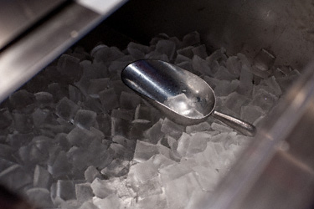
Ice machines

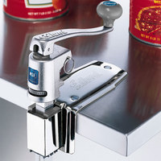
Match the words answers

1. d | 2. e | 3. a | 4. c | 5. b

