WHAT IS A MEN’S SHED?

The modern Men’s Shed is an updated version of the “shed in the backyard” that has long been a part of Australian culture. If you looked inside one you might see a number of men restoring furniture, perhaps restoring bicycles for a local school, maybe making Mynah bird traps or fixing lawn mowers or making a kids cubby house for Camp Quality to raffle. You might also see a few young men working with the older men learning new skills and maybe also learning something about life from the men they work with. You will see tea-bags, coffee cups and a comfortable area where men can sit and talk.

So what is so special about A Men’s Shed?
Most men have learned from our culture that they don’t talk about feelings and emotions. There has been little encouragement for men to take an interest in their own health and well-being. Unlike women, most men are reluctant to talk about their emotions and that means that they usually don’t ask for help. Probably because of this many men are less healthy than women, they drink more, take more risks and they suffer more from isolation, loneliness and depression. Relationship breakdown, retrenchment or early retirement from a job, loss of children following divorce, physical or mental illness are just some of the problems that men find it hard to deal with on their own.
Good health is based on many factors including feeling good about yourself, being productive and valuable to your community, connecting to friends and maintaining an active body and an active mind. Becoming a member of a Men’s Shed gives a man that safe and busy environment where he can find many of these things in an atmosphere of old-fashioned mateship. And, importantly, there is no pressure. Men can just come and have a yarn and a cuppa if that is all they’re looking for.
Because men don’t make a fuss about their problems, these problems have consistently been either ignored or swept under the mat by both our health system and our modern society. It’s time for a change and the Men’s Shed movement is one of the most powerful tools we have in helping men to once again become valued and valuable members of our community.

A Men’s Shed is any community-based, non-profit, non-commercial organisation that is accessible to all men and whose primary activity is the provision of a safe and friendly environment where men are able to work on meaningful projects at their own pace in their own time in the company of other men. A major objective is to advance the well-being and health of their male members
Members of Men’s Sheds come from all walks of life - the bond that unites them is that they are men with time on their hands and they would like something meaningful to do with that time.
A good Men’s Shed operates a safe and happy environment where men are welcome to work a project of their choice in their own time and where the only ‘must’ is to observe safe working practices. All in a spirit of mateship.

AFS Men’s Shed
@ PCYC Rockhampton

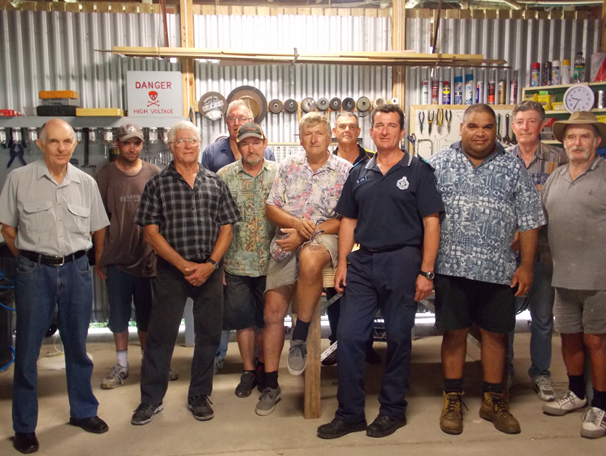

Tucked away on the ground floor of the Rockhampton PCYC building; is the AFS Pharmacies – Men’s Shed.

The focus of this local Men’s shed is to;
- Boost membership of males who seek mateship and a belonging.
- Give the unemployed and retirees a strong sense of worth.
- Provide youth with guidance & self-esteem, through provision of basic trade knowledge and to enhance employment prospects.
- Strengthen the community through undertaking various community support projects.

As the Men’s Shed name (and position) suggests, the Men’s Shed has a wonderful grounding for ongoing success and growth, particularly given the significance of the two supporting organisations, who are passionate about ensuring the ongoing success.

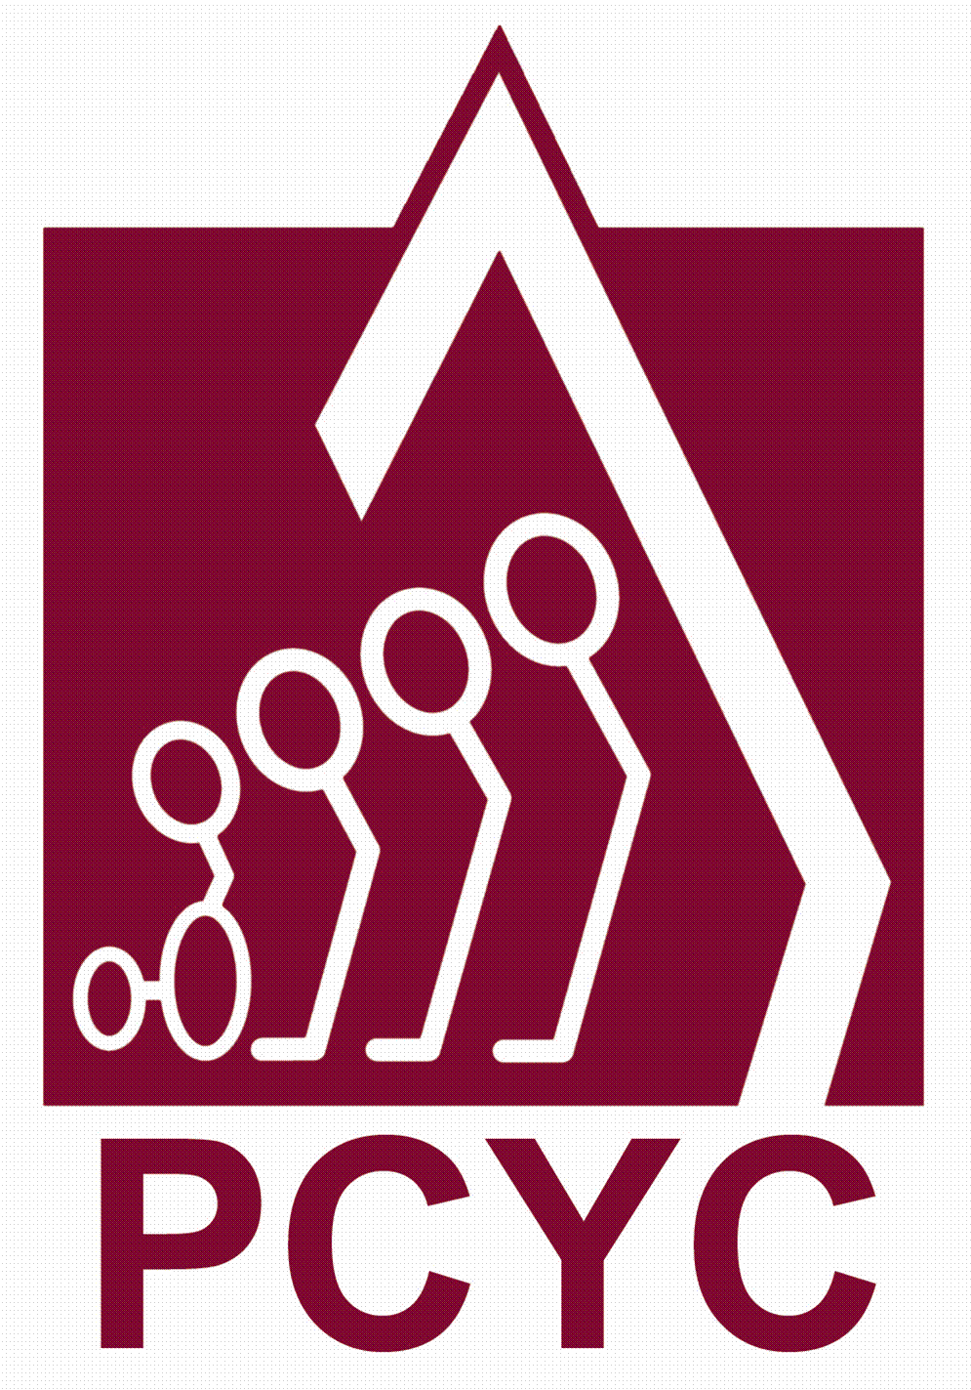PCYC Rockhampton

Police-Citizens Youth Club Rockhampton is a Not for Profit organisation that aims to enhance our community through youth development. This is encouraged through a caring environment with a wide range of activities for all ages.

The local PCYC, recognises both the excellent “community support” values of the Men’s Shed movement itself, as well as the excellent fit the Men’s Shed can offer as a mentor to the local youth of the PCYC.

AFS Pharmacies, Rockhampton

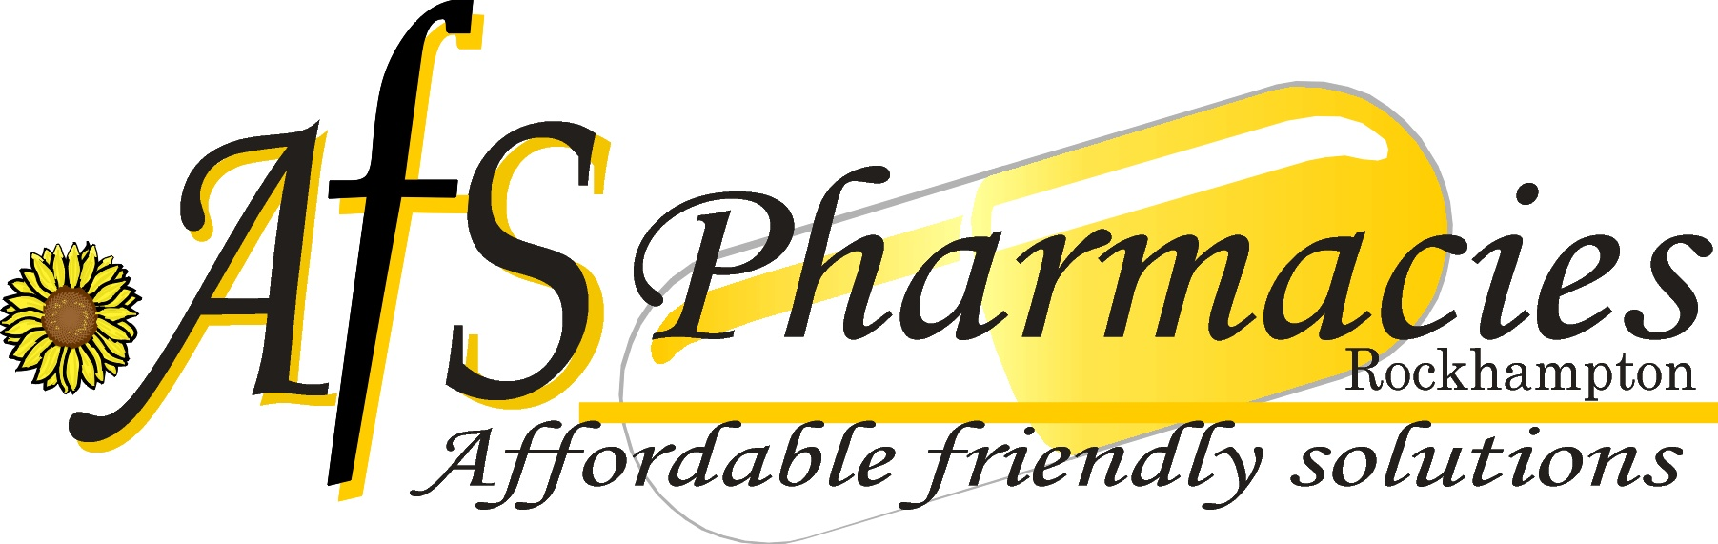As a local, community owned organisation who (through their community pharmacies) has a keen interest in the health and wellbeing of the local community, AFS Pharmacies has chosen to enhance the health & wellbeing of the (male) community by passionately supporting this local Men’s Shed. With over 120 years of experience operating in the local community, AFS Pharmacies knows and understands the value of community support.

The strengths and support services provided by these two organisations, will guarantee ongoing success.

