Wisdom from Stillness

Weekend Meditation Retreat with Bhante Akāliko

Meditation is not just to de-stress from life's busy-ness, it has a far deeper potential to reveal insights about the meaning of life.
Join Bhante Akāliko for this weekend retreat and learn how to transform your practice into a powerful tool to cut through ignorance and illuminate your mind with wisdom.

This workshop is suitable for both new and experienced meditators.

About the Teacher
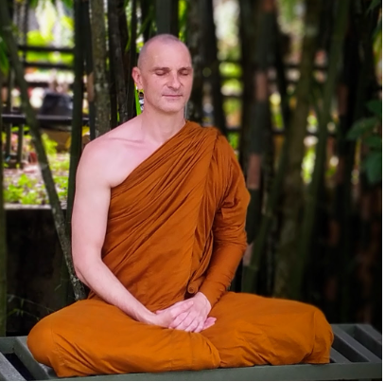
Akāliko Bhikkhu is an Australian monk in the Theravada forest tradition. He is the spiritual director of Little Dust and founder of Rainbodhi LGBTQIA+ Buddhist Community. Bhante Akāliko is also the spiritual advisor of Central West Buddhists and a chaplain at Western Sydney University. He sits on the boards of the Buddhist Council of NSW and the Federation of Australian Buddhist Councils.
Bhante Akāliko went forth as a monastic in 2016 and received full ordination with Ajahn Brahm at Bodhinyana monastery in 2017. He later stayed for several years with Bhante Sujato at the Monastery at the End of the World in Sydney and now lives as a wandering monk.

Dates: Friday 24th March 5 pm – Sunday 26th March 4 pm
Location: Discovery Parks Yeppoon, 760 Scenic Highway, Kinka Beach, Qld
Information: Sama 0478 630 888 Robert: 0429 993 606
rockhamptoninsightmeditation@gmail.com
Fee: $ 250 This includes accommodation & all meals (vegetarian). This is to cover the costs of the workshop.
The teachings are given free. Dana (or donations to teacher) are very welcome. Teachers rely on donations as their sole income.

