ONE DAY MINDFULNESS WORKSHOP
How mindfulness transforms suffering: theory and practice
with Timothea Goddard

Mindfulness is a practice that involves paying attention in certain ways. It also has a deep and ancient logic to it, that illuminates how we might use our mind in a way that it becomes a friend rather than a tormentor. We will explore how mindfulness reduces our suffering through training in three ways:

- Where we pay attention
- How we pay attention, and
- The view we bring to what we discover

In this workshop we will explore both the practice and the theory of mindfulness meditation in a way that is empowering, user-friendly and accessible. There will be lots of time for experimenting with various practices, and in reflection about the learning. We will also bring some clarity to how our view of things really influences how much we suffer – in big and small ways.
Together we’ll explore:
- mindfulness meditation and the logic within it
- awareness of the body, senses, thoughts, feelings and emotions
- cultivating calm and insight, compassion and equanimity
- meditation in stillness and moving (stretching and walking)
- connection to nature and our context in the world

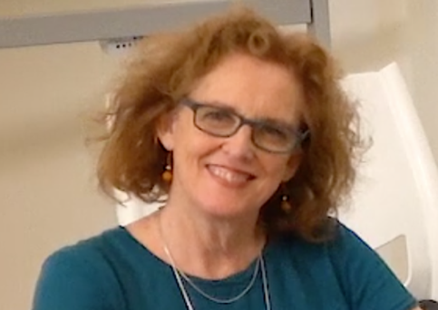
Timothea Goddard (Tim) has been practicing yoga and meditation (in the Vipassana tradition) since her early twenties, having also spent some years practicing Zen and Aikido. She sees meditation as a pragmatic way of inviting people into recognizing their own basic goodness - in terms of clarity, courage and wisdom – and how to bring this goodness into the world. She is acknowledged as a pioneer in bringing Mindfulness-Based Stress Reduction (MBSR) and associated programs to Australia over the past 17 years. She has worked in private practice for 35 years as a developmental psychotherapist having trained in humanistic, psychodynamic, body-based and systemic ways of exploring challenges in life and relationships. Her latest forays into learning has been in Internal Family Systems, trauma sensitive yoga teacher training and Clean Language.
She is founding director of Openground – an Australia-wide network of clinicians and teachers offering MBSR and related mindfulness programs, workshops and retreats, and of the Mindfulness Training Institute – Australia and New Zealand – a not-for-profit which offers teacher training and Vipassana retreats.
This workshop is for both new and experienced meditators.
When: Sunday 28 November 2021
Time: 9:00 am – 5:00 pm
Where: Women’s Health Centre, 225 Bolsover St, Rockhampton (entrance opposite VibeFitness)
Cost
$50
Payment is by cash in the morning.
This covers basic pay for the teacher. Further donations or dana to Tim are welcome.
Bookings
Contact Sama - 0478 630 888 or Irena - 0417 259 669
or email rockhamptoninsightmeditationatgmail.com with your contact details by Thursday 25 November
Details
Lunch, tea & coffee provided
Chairs are provided at the Centre, but please BYO cushion & folding chair or mat

