MINDFULNESS & LOVING KINDNESS MEDITATION
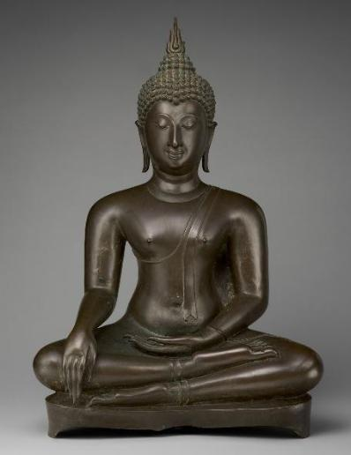

The mind is constantly wondering to the past and to the future. This gives stress to the mind. In these sessions we focus on the Buddha’s “Four foundations of mindfulness”. Mindfulness of body, feelings, thoughts and mental states.

The benefits of being mindful are immense. Mindfulness helps keep the mind and body healthy. It helps us develop and maintain calmness, focus on other wholesome states of mind. These are not only beneficial for us, but the benefits flow on to others we come in contact with.
Loving kindness meditation is giving love to yourself & to all others and so having positive emotions
Sama is a Buddhist nun in Theravada tradition. She has been practicing mindfulness for over 20 years and has studied with a range of mindfulness teachers.

Every Saturday 4.30 pm – 5.30 pm from 5 February 2023

At Women’s Health Centre 225 Bolsover St corner of Derby St Rockhampton 4700 entrance gate opposite Vibe Fitness

BYO cushion chairs provided

Attendance: Free donations to Women’s Health Centre are very welcome

Contact: rockhamptoninsightmeditation@gmail.com 0478630888 text preferred
ALL WELCOME

